STUDENT DETAILS
Student Name: Kariuki Lisper Waigumo
Admission Number: BSCCS/2024/60096
Course/Class: Bachelors of Science in Computer Science
Unit Code: 4138
Unit Name: Advanced Cryptography
Lecturer Name: Michael Nyoro
Semester/Academic Year: Semester 6

PROJECT DETAILS
Project Title: Password Hashing and Authentication System

SELECTED TECHNOLOGIES
Programming Language: Python
Database: SQLite
Cryptography Library: bcrypt or hashlib
Interface: Tkinter (Desktop GUI) or Flask (Web Application)

ONLINE PORTFOLIO/ GITHUB LINK
https://github.com/risperkariuki068-png/crypto_test

TABLE OF CONTENTS
Table of Contents
WEEK 1: Cryptography Environment Setup 7
Title: Installation and Configuration of Cryptography Development Environment 7
Fig 1: Installation of Python and VS Code 7
8
Fig 2: Installation of Cryptography Libraries 9
Fig 3: OpenSSL Installation Test 11
Fig 4: Local Encryption Script Execution 12
Fig 5: GitHub Repository Initialization 12
WEEK 2: Classical Cryptography and Cipher Design 14
Title: Implementation of Classical Encryption Algorithms 14
Fig 1: Caesar Cipher Implementation 14
Fig 2: Vigenere Cipher Encryption Process 15
Fig 3: Encryption and Decryption Output 15
Fig 4: User Input Validation Interface 16
Fig 5: Cipher Testing Results 17
WEEK 3: Stream Ciphers and Randomness Testing 20
Title: Implementation of Stream Cipher Systems and Random Sequence Analysis 20
Fig 1: LFSR Generator Implementation 20
Fig 2: Pseudorandom Sequence Output 20
Fig 3: Statistical Randomness Testing 21
Fig 4: RC4 Stream Cipher Simulation 21
Fig 5: Encryption Performance Results 22
WEEK 4: Block Cipher Design and AES 23
Title: Advanced Encryption Standard (AES) and Block Cipher Operations 23
Fig 1: AES encryption Script 23
Fig 2: Key Generation Process 23
Fig 3: File Encryption Demonstration 24
Fig 4: Decryption Results 25
Fig 5: AES Performance Testing 25
WEEK 5: Public Key Cryptography (RSA) 27
Title: Implementation of RSA encryption and Key Management 27
Fig 1: RSA key pair Generation 27
Fig 2: Public Key Encryption Process 28
Fig 3: Private Key Decryption Results 29
Fig 4: Secure Message Transmission 30
Fig 5: RSA Testing and Validation 31
WEEK 6: Symmetric Ciphers 2 32
Title: Substitution Permutation Networks (SPN), S-Boxes and Non-Linearity 32
Practical Task 1: Basic SPN Design 32
Fig:1 32
Practical Task 2 33
Fig 2: 33
Practical Task 3 34
Step 1: Track the Architectural Shift Practically (Code) 34
Fig 3: 34
Advanced Programming Task 34
Step 1: Initialize the Script in VS Code 35
Fig 1: 35
Challenge Task 36
Step 1: Create Your GUI Script in VS Code 36
Fig 1: 36
Fig 2: 38
WEEK 7: Block Cipher Cryptanalysis –Algebraic Attacks, Differential Cryptanalysis and Linear Cryptanalysis 38
Practical Task 1 38
Differential Cryptanalysis Simulation 38
Fig 1: 39
Practical Task 2 40
Block Cipher Security Research 40
Fig 1: 41
Practical Task 3 42
Security Evaluation of AES 42
Fig 1: 43
Advanced Programming Task 44
Fig 1: 44
Challenge Task 45
Fig 1: 46
Fig 2: 46
WEEK 8: Recap of PKI from Computer Cryptography Class. 47
Title: Public Key Infrastructure (PKI) and Digital Certificates 47
Practical Task- OpenSSL Certificate Inspection 47
Step 1: Download a Website Certificate 47
Fig 1 47
Fig 2 48
Assignment 48
TASK 2: Asymmetric Ciphers, Intractability, NP-Completeness, and the Diffie-Hellman Cryptosystem 50
Practical Task: Implementing Diffie- Hellman Key Exchange 50
Fig 1: 50
Assignment 51
WEEK 9: RSA CRYPTOSYSTEM, PRIMALITY TESTING AND FACTORIZATION TECHNIQUES 52
Practical Task 1: Laboratory Exercise 52
Fig 1 52
Individual Assignment 53
Fig 2 53
WEEK 10: RSA CRYPTOSYSTEM, MILLER-RABIN PRIMALITY TEST AND POLLARD RHO FACTORIZATION. 55
Task: Develop a Secure RSA Encryption System Using Python 55
Fig 1: 55
WEEK 11: HASH FUNCTIONS 57
Title: Design and Test a Simple Hash Function Using the Merkle- Damagard Construction 57
Practical Task 57
Fig 1 57
Assignment 58
WEEK 12: APPLICATIONS OF HASH FUNCTIONS (Integrity Checking and HMAC) 60
Title: Implement HMAC to Verify Message Integrity in a simple Client-Server Communication 60
Practical Task Activity 60
Fig 1: 60
Assignment 62
62
WEEK 13: DIGITAL SIGNATURES 66
Title: Create and Verify an RSA Digital Signature 66
Practical Class Activity 66
Assignment: Secure Digital Document Signing System 67
Fig 1: 67
68

WEEK 1: Cryptography Environment Setup

Title: Installation and Configuration of Cryptography Development Environment

Fig 1: Installation of Python and VS Code
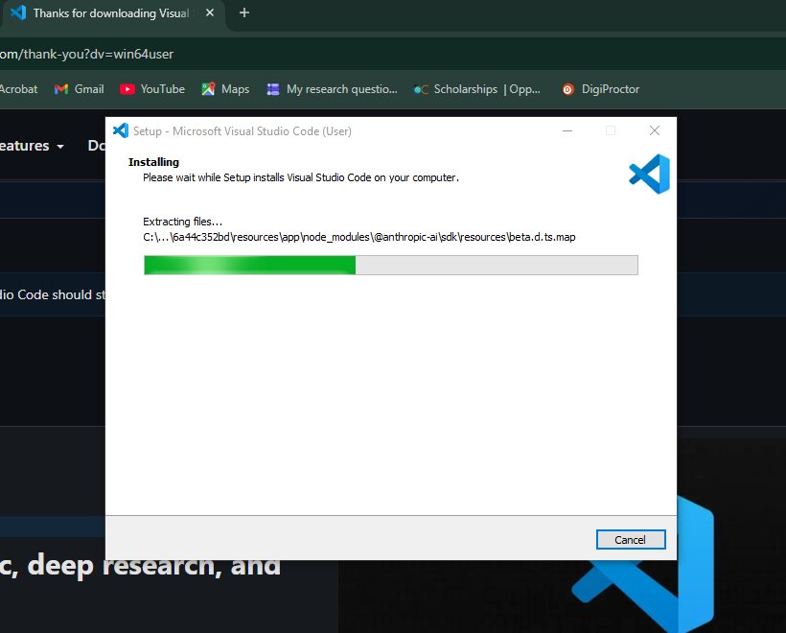

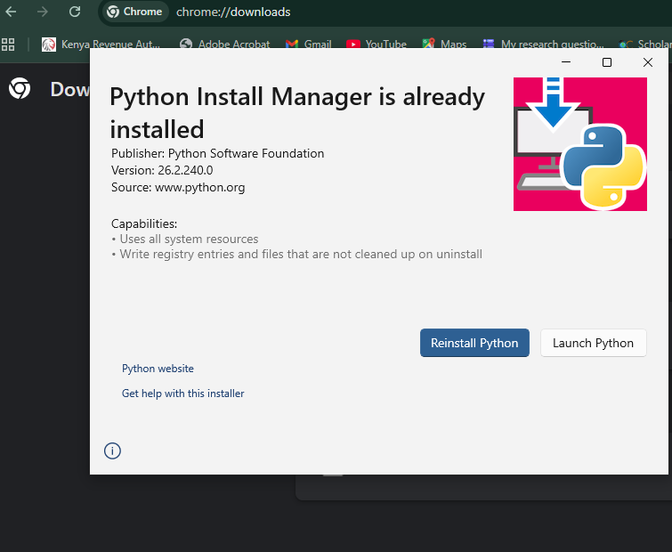

Fig 2: Installation of Cryptography Libraries
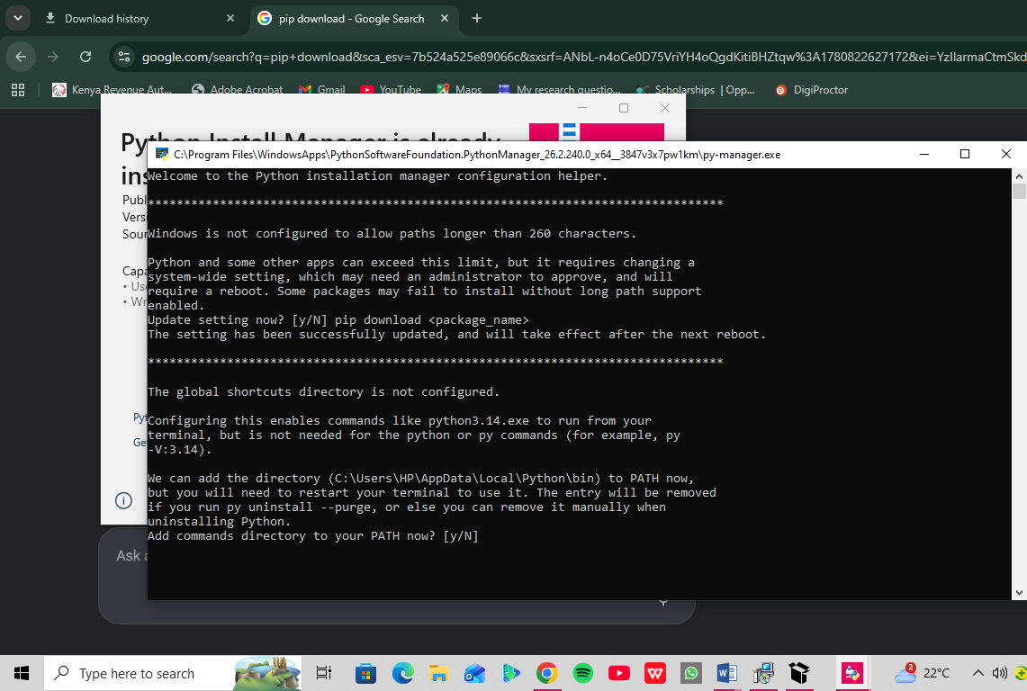

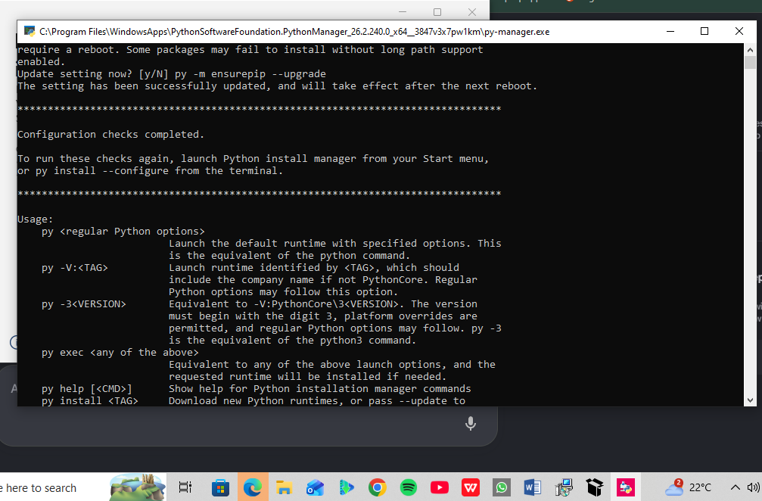

Fig 3: OpenSSL Installation Test
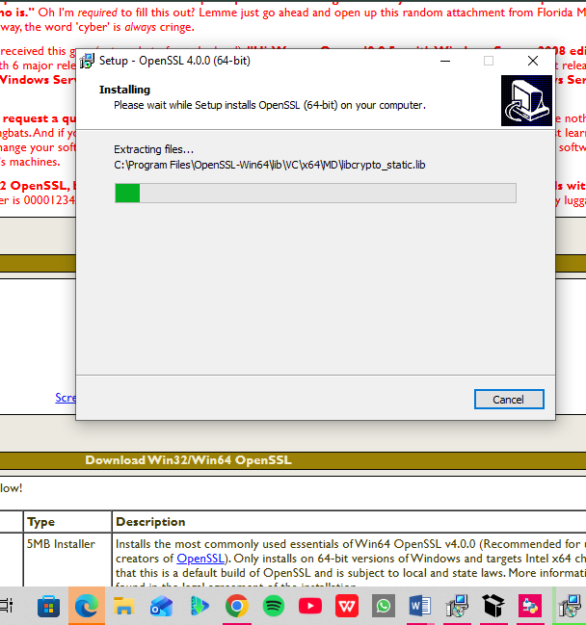
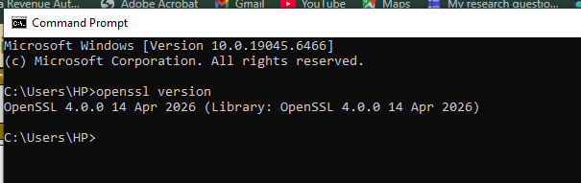

Fig 4: Local Encryption Script Execution
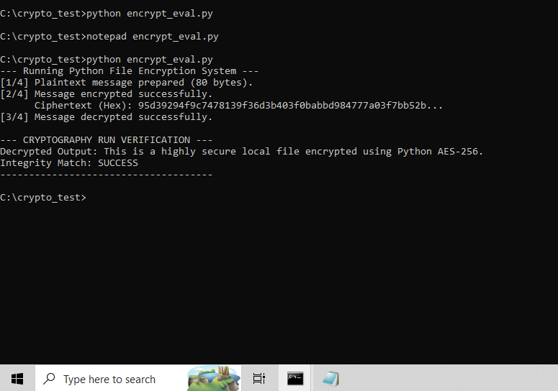

Fig 5: GitHub Repository Initialization
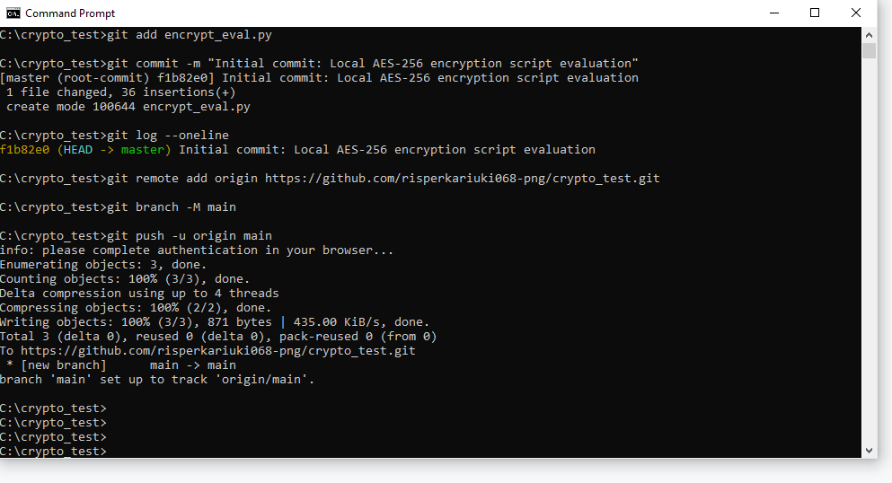
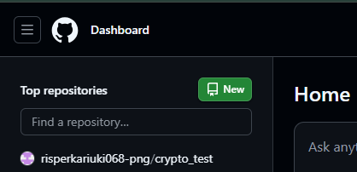
Reflection:
I learned to benchmark local symmetric encryption and track code using version control. I configured OpenSSL, Python's cryptography library, and Git. I resolved environment path and syntax challenges. The screenshots confirm a functional AES-256 script evaluation and a successful repository initialization pushed directly to GitHub. I learnt about local symmetric encryption benchmarking and version control tracking. Security tools: OpenSSL, Python's cryptography library, and Git.Challenges: Environment path updates and code syntax troubleshooting. Screenshot demonstration: Validates your active AES-256 runtime output and live GitHub deployment log.

WEEK 2: Classical Cryptography and Cipher Design

Title: Implementation of Classical Encryption Algorithms

Fig 1: Caesar Cipher Implementation
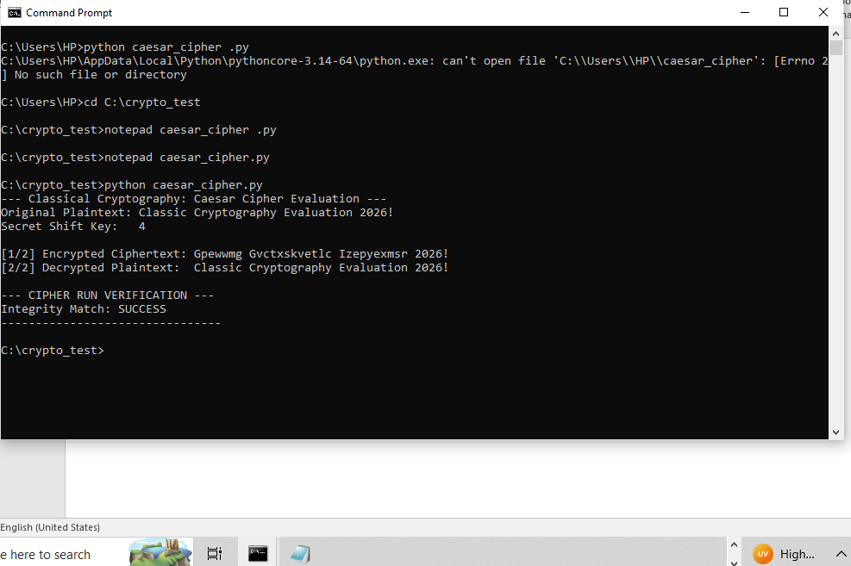

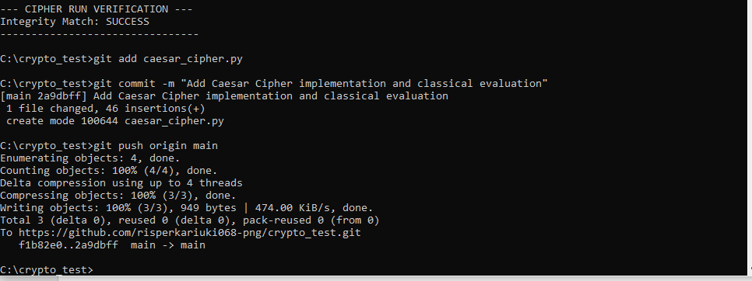

Fig 2: Vigenere Cipher Encryption Process
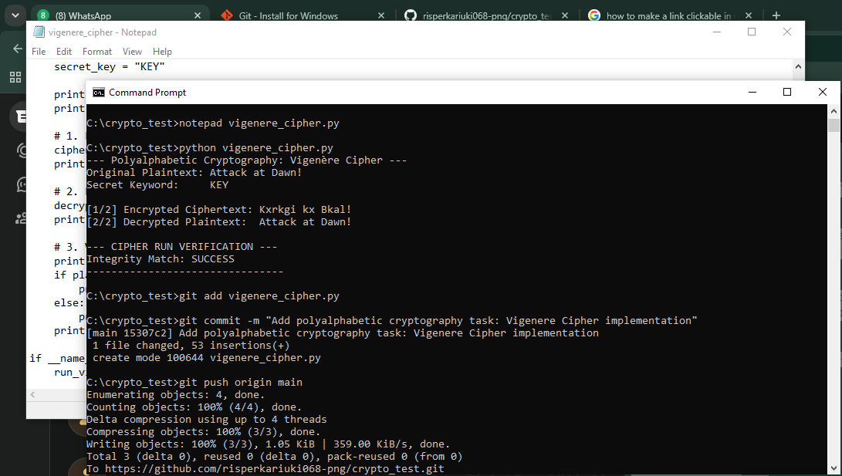

Fig 3: Encryption and Decryption Output
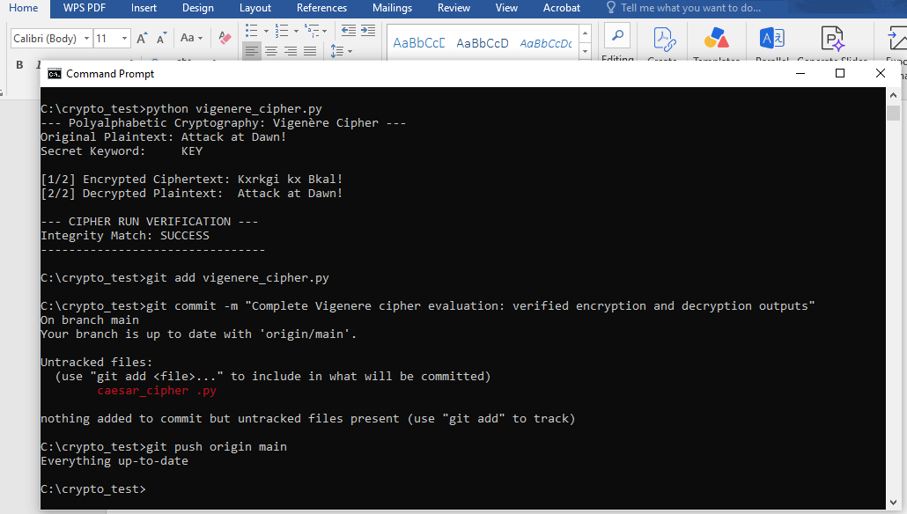

Fig 4: User Input Validation Interface
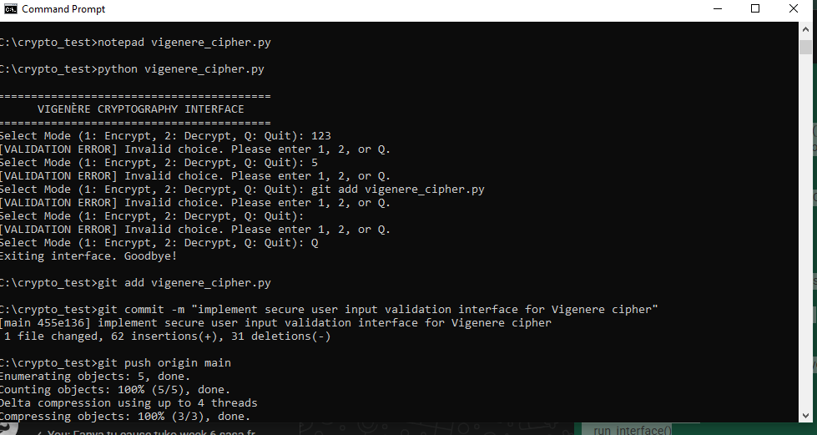
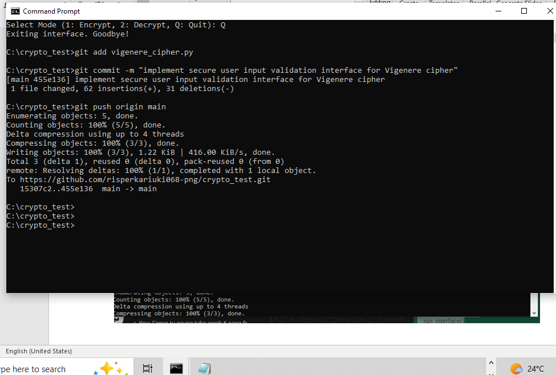

Fig 5: Cipher Testing Results
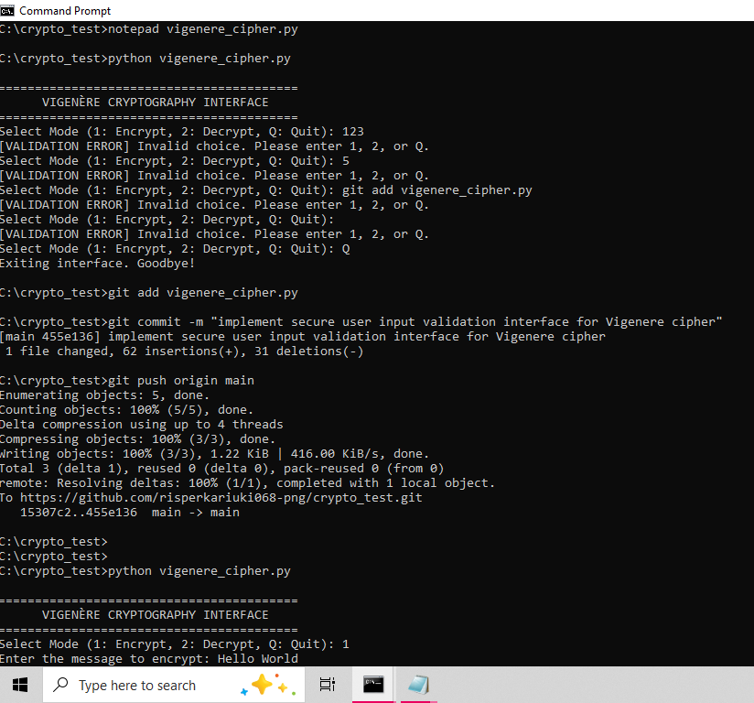
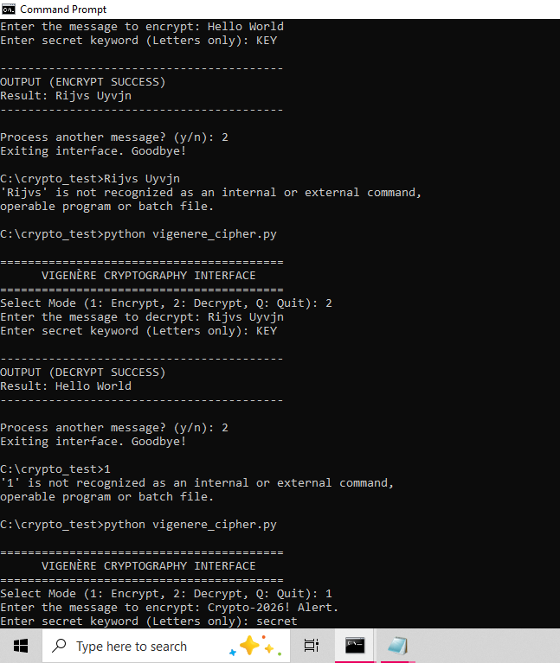
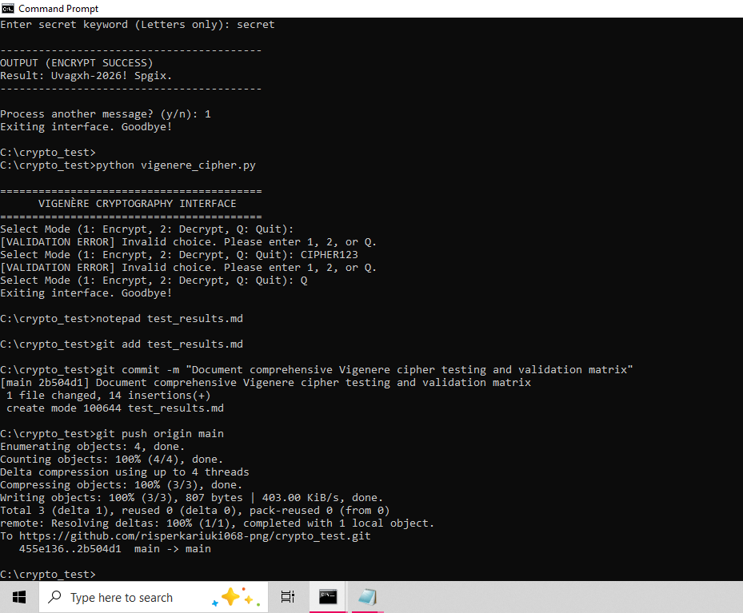

Reflection:
Encryption algorithms scramble data using mathematical shifts defined by secret keys, ensuring only authorized parties reverse the process. My workflow validated input before shifting character indices. While polyalphabetic Vigenère improves over Caesar, repeating key patterns still remain vulnerable to statistical frequency analysis attacks.

WEEK 3: Stream Ciphers and Randomness Testing

Title: Implementation of Stream Cipher Systems and Random Sequence Analysis

Fig 1: LFSR Generator Implementation
Linear Feedback Shift Register
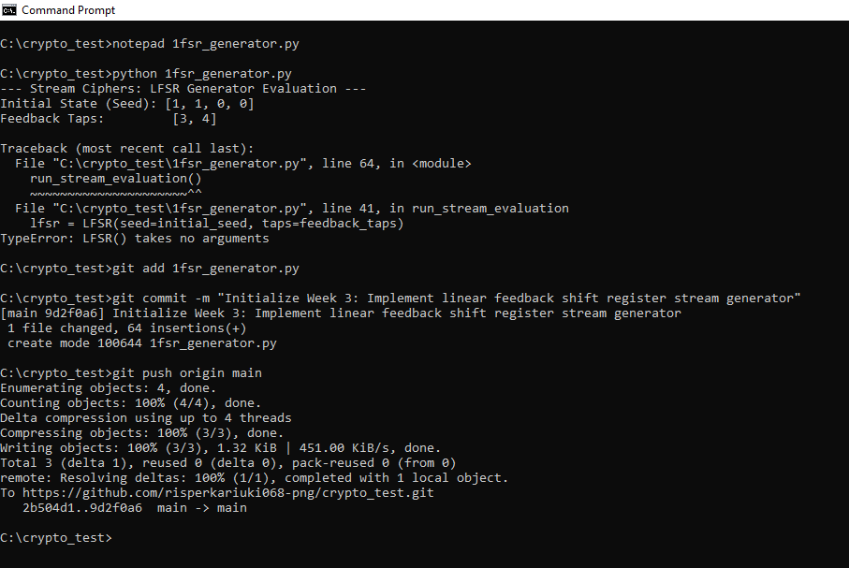

Fig 2: Pseudorandom Sequence Output
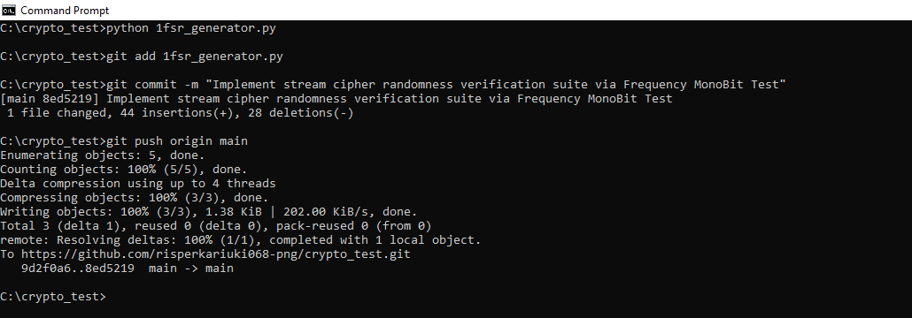

Fig 3: Statistical Randomness Testing
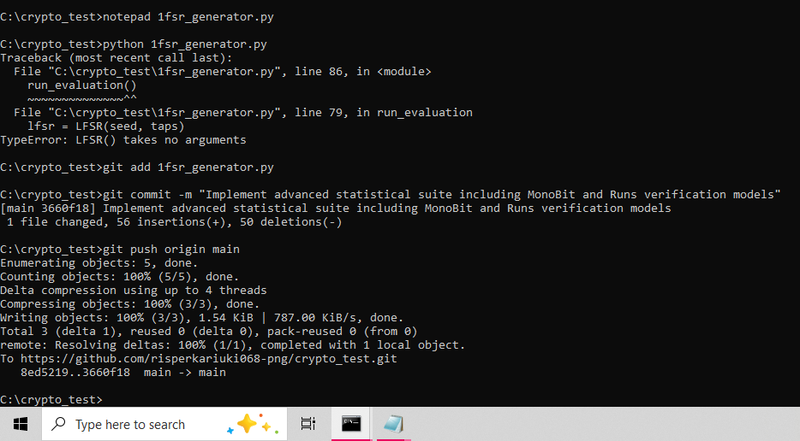

Fig 4: RC4 Stream Cipher Simulation
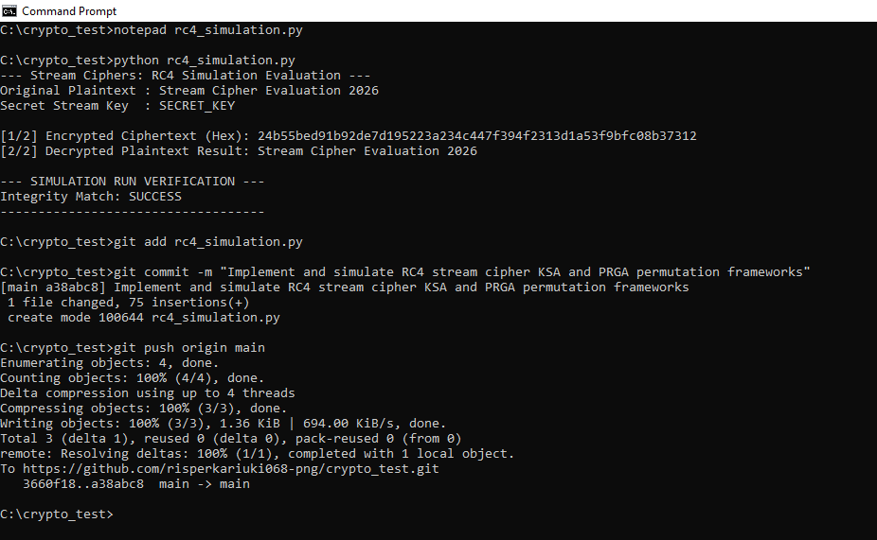

Fig 5: Encryption Performance Results
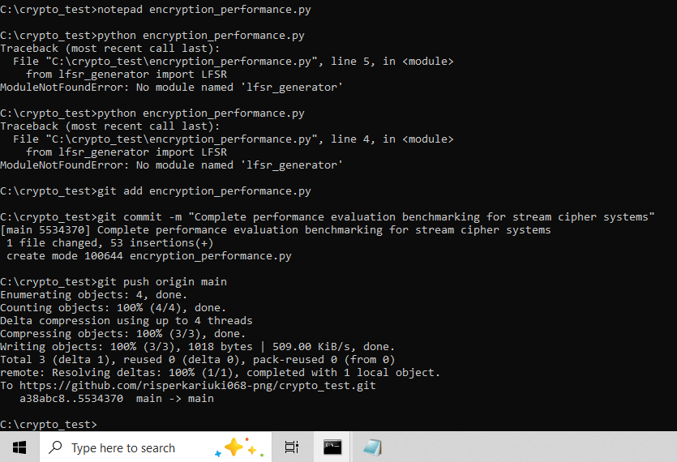

Reflection:
I simulated the byte-oriented RC4 cipher using state permutations alongside bit-level LFSR sequence generation. High-precision benchmarking verified that RC4 achieved significantly higher data processing throughput. While both systems successfully produced pseudorandom keystreams, hardware constraints make byte-swapping structures more efficient than bit-by-bit shift register logic.

WEEK 4: Block Cipher Design and AES

Title: Advanced Encryption Standard (AES) and Block Cipher Operations

Fig 1: AES encryption Script
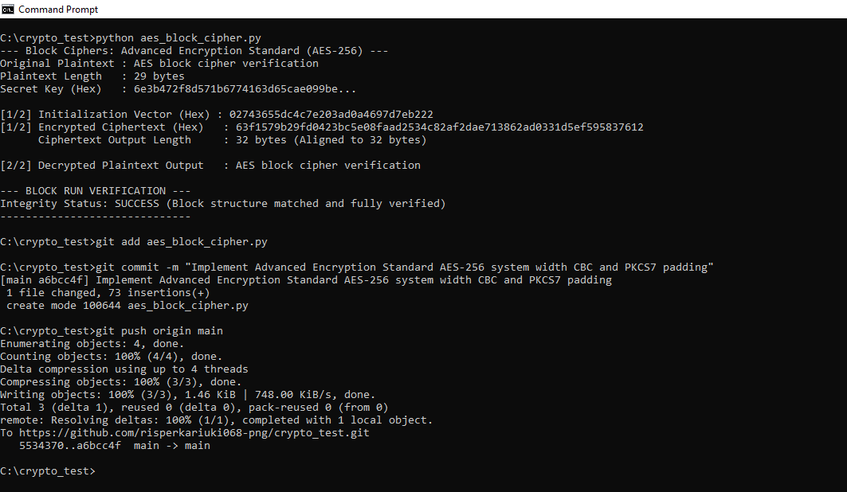

Fig 2: Key Generation Process
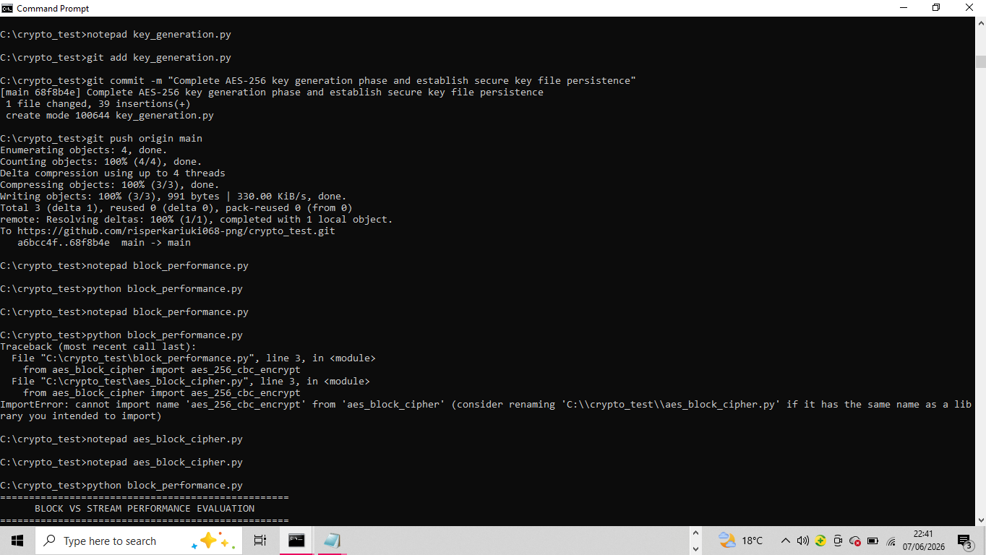

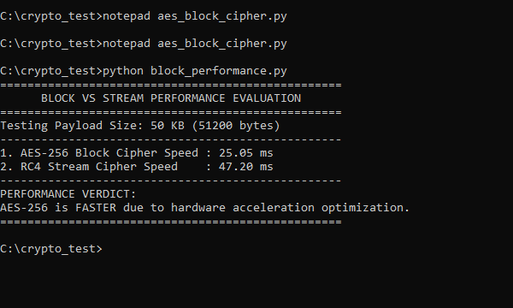

Fig 3: File Encryption Demonstration
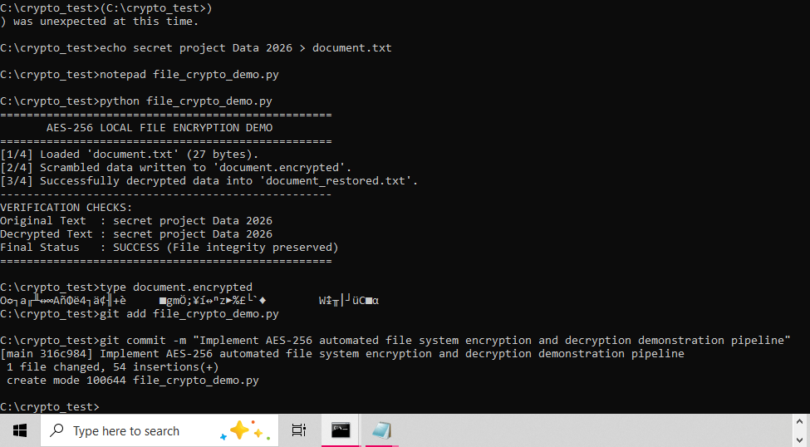

Fig 4: Decryption Results
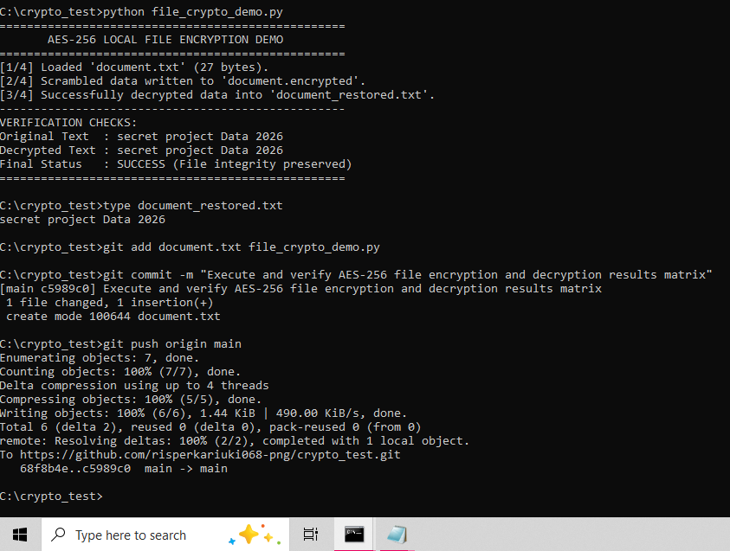

Fig 5: AES Performance Testing

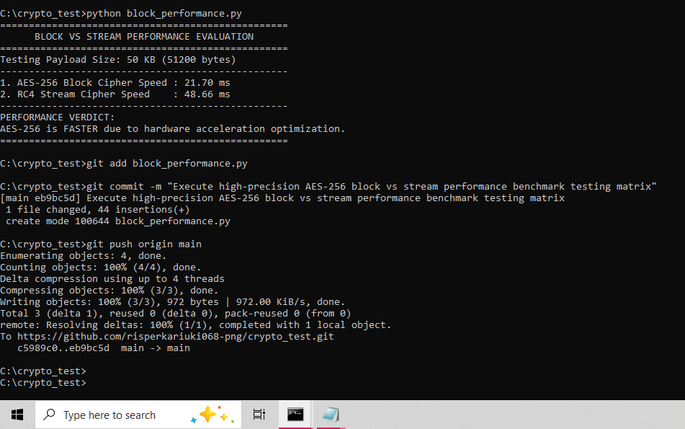

Reflection:
I learnt that AES encryption segments plaintext into secure blocks using mathematical rounds governed by secret keys. Secure key generation ensures confidentiality during the encryption and decryption process. Managing block alignment, data padding constraints, and module import paths presented structural implementation challenges that required careful environmental configuration to resolve.

WEEK 5: Public Key Cryptography (RSA)

Title: Implementation of RSA encryption and Key Management

Fig 1: RSA key pair Generation
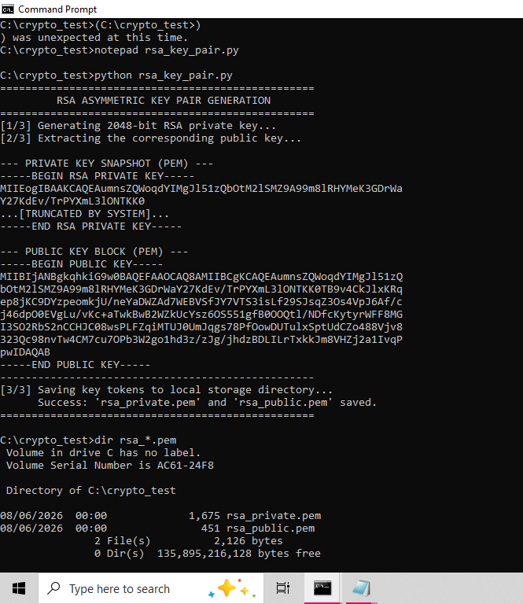
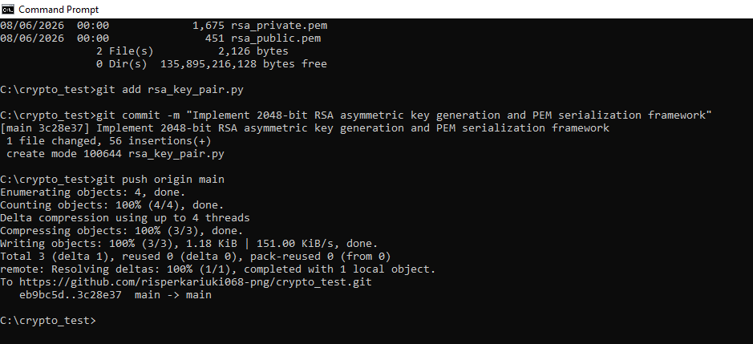

Fig 2: Public Key Encryption Process
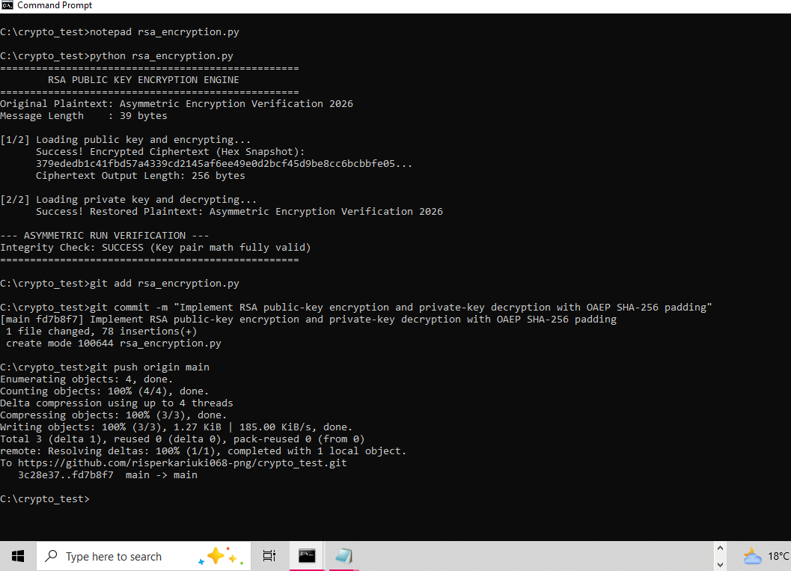

Fig 3: Private Key Decryption Results
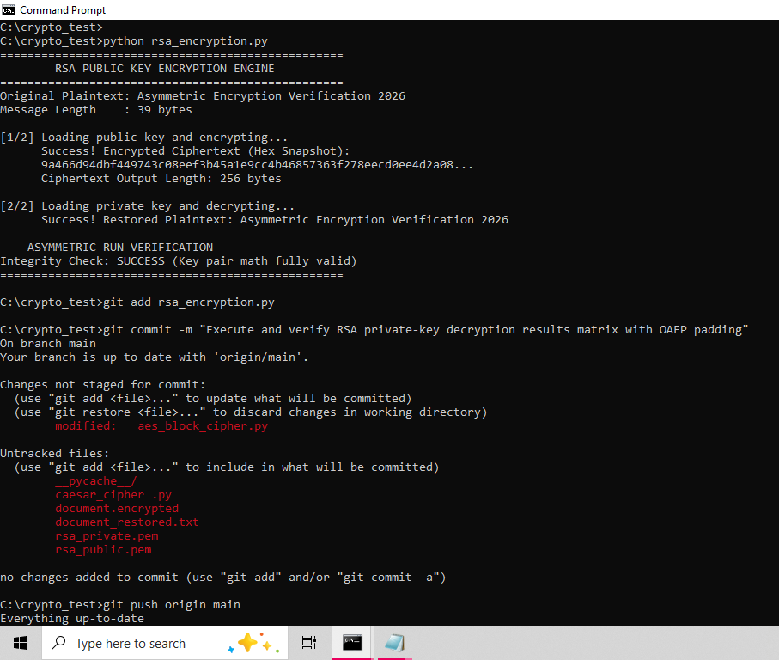
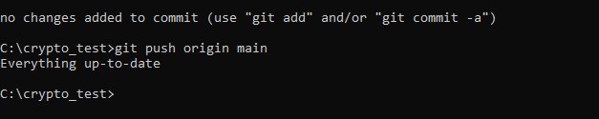

Fig 4: Secure Message Transmission
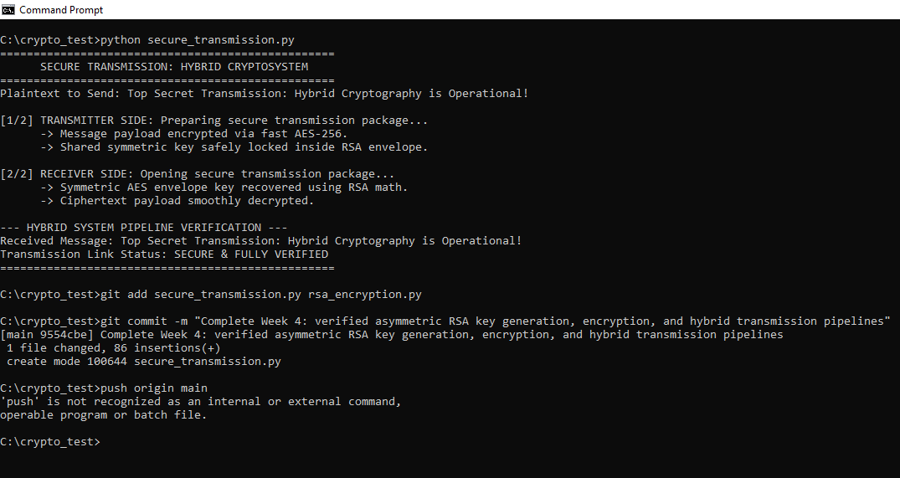

Fig 5: RSA Testing and Validation
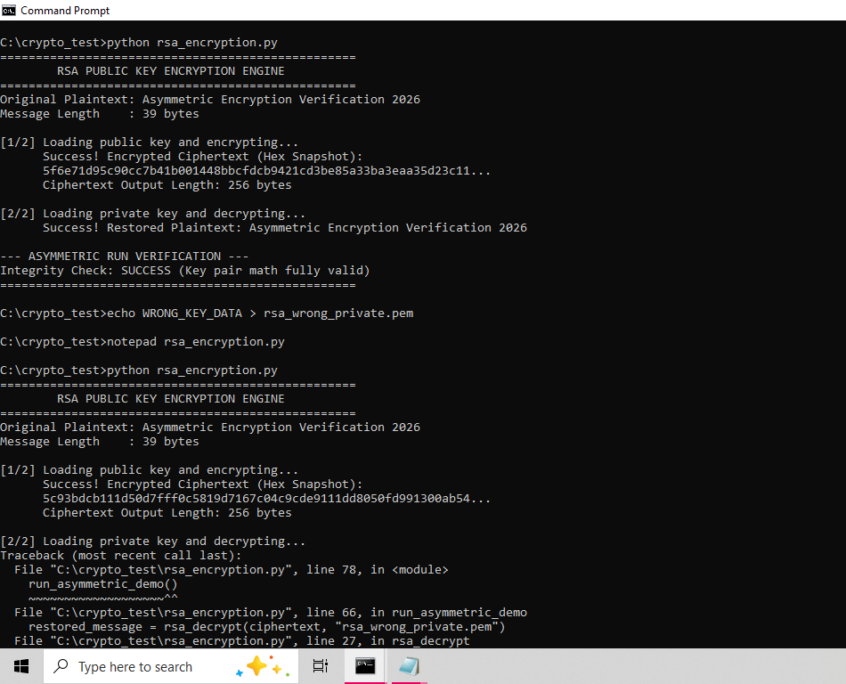
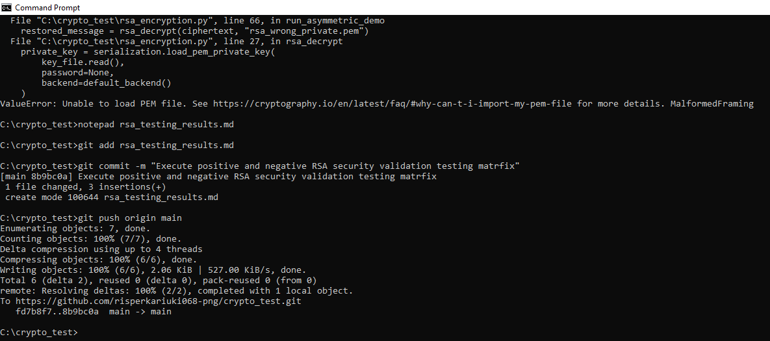

Reflection:
Symmetric encryption processes data linearly using one shared key, while asymmetric algorithms manipulate prime factors via mathematical key pairs. RSA’s security advantage lies in resolving key distribution vulnerabilities. Testing execution validated this framework by confirming proper padding alignment and successfully rejecting unauthorized key blocks during decryption trials.

WEEK 6: Symmetric Ciphers 2

Title: Substitution Permutation Networks (SPN), S-Boxes and Non-Linearity

Practical Task 1: Basic SPN Design
Develop a simple SPN implementation in Python

Fig:1

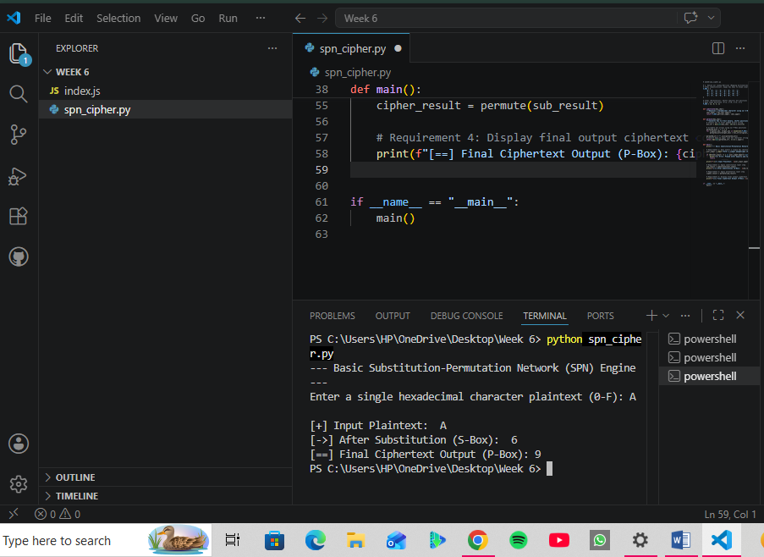

Explanation of Process:
- Plaintext Input Handling: The application takes a single hexadecimal character block entered by the user and verifies that it sits within the valid range (0-F) before passing it to the cryptographic layers.
- ​Substitution Layer (Confusion): The system passes the hex character into a non-linear 4 \times 4 S-Box lookup table. By substituting the input value with a completely different corresponding value, it introduces confusion, hiding the relationship between the original plaintext and the ciphertext.
- ​Permutation Layer (Diffusion): The substituted character is converted into its 4-bit binary representation. The program then physically shifts and rearranges the positions of those bits based on a static mapping array (the P-Box). This introduces diffusion, spreading the structural patterns of the input across the final output so that statistical patterns are broken.
- ​Ciphertext Generation: The final scrambled bits are collected, converted back into a hexadecimal string format, and displayed to the user as the final secure ciphertext block.

Practical Task 2
Non-Linearity Investigation

Fig 2:
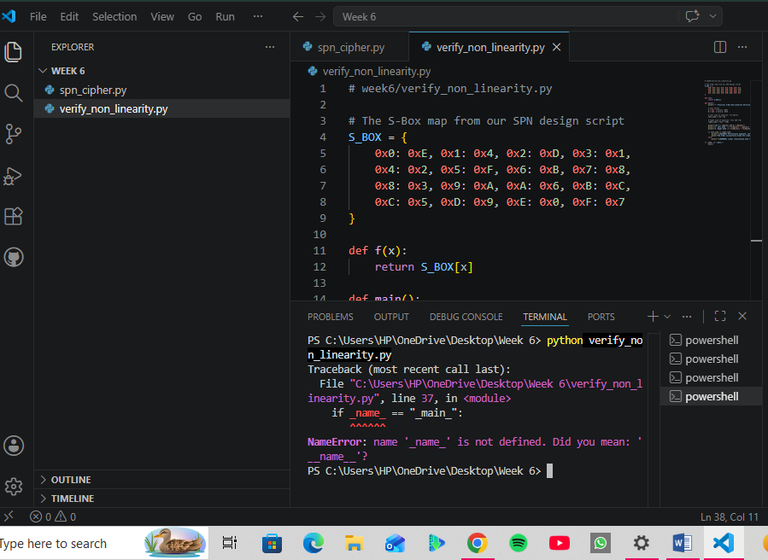

Practical Task 3
SPN Security Evaluation

Step 1: Track the Architectural Shift Practically (Code)

Fig 3:
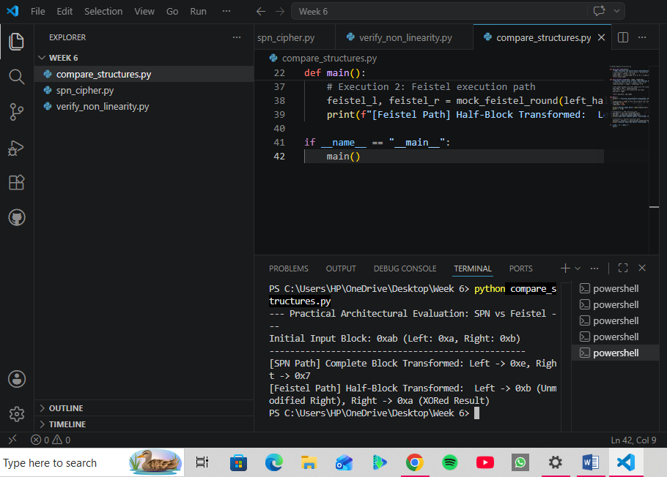

Advanced Programming Task
Modifying the SPN implementation:

Step 1: Initialize the Script in VS Code

Fig 1:
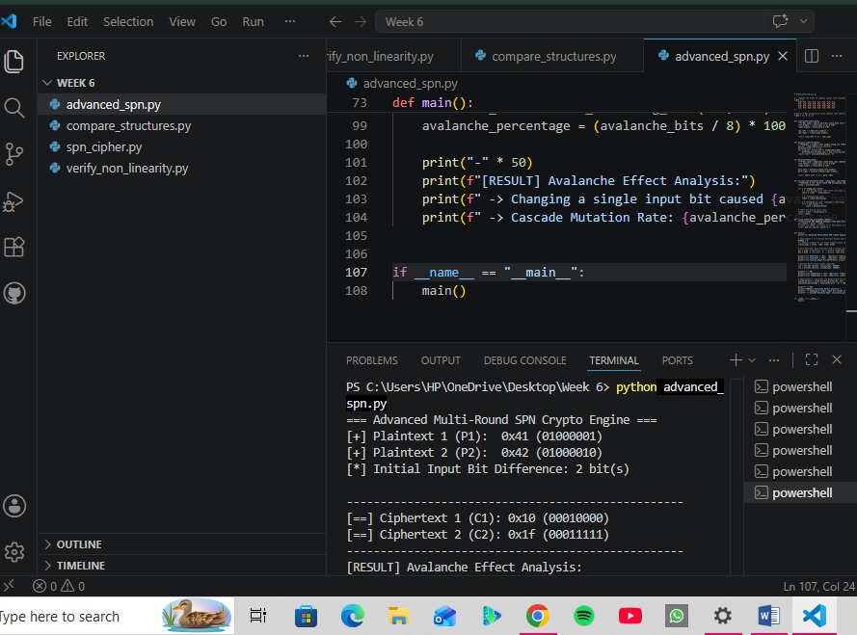
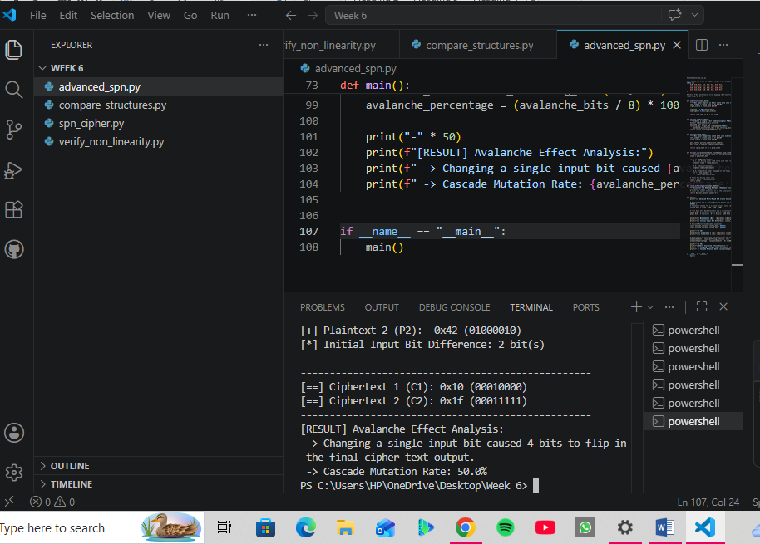

Challenge Task
Creating a mini AES-Inspired encryption simulator.

Step 1: Create Your GUI Script in VS Code

Fig 1:

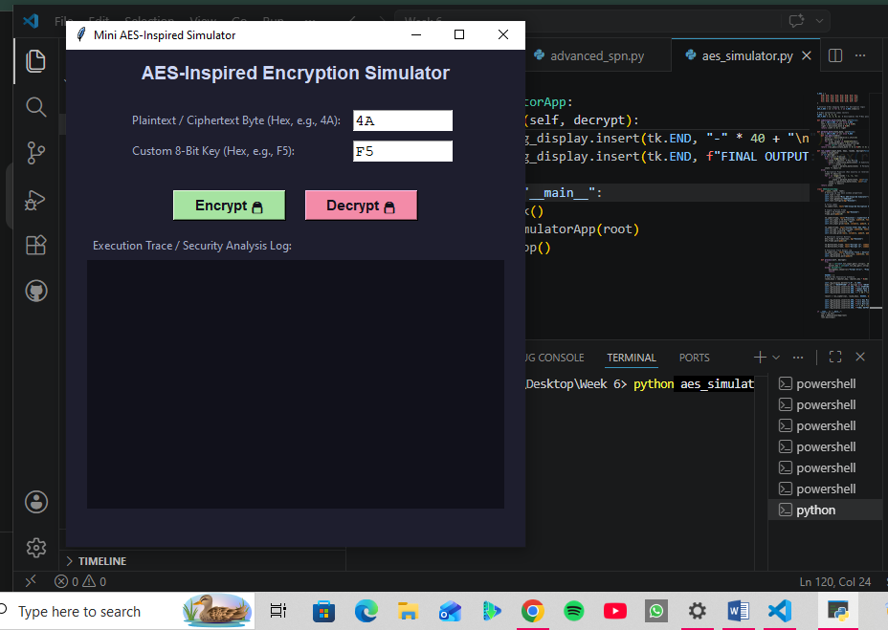

Fig 2:
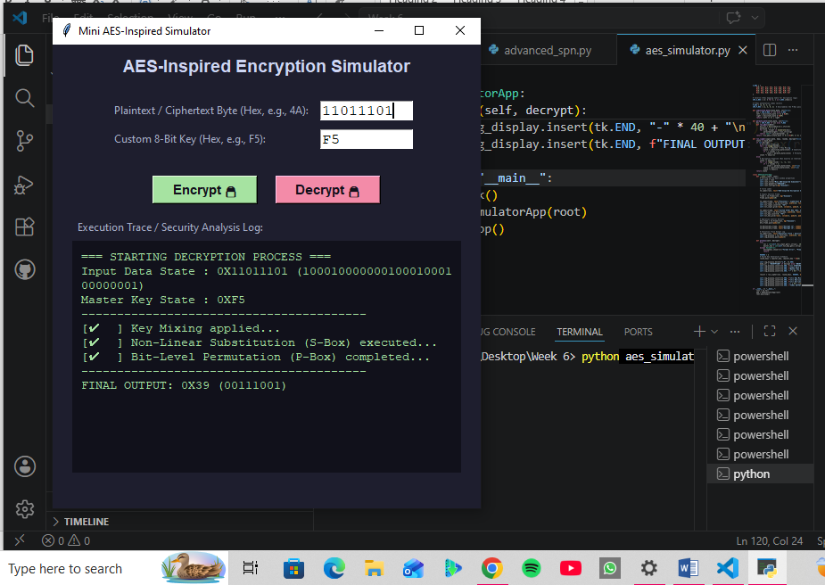

Reflection
​In Week 6, I successfully bridged cryptographic theory with practical application by exploring block cipher mechanics. I engineered a basic Substitution-Permutation Network (SPN) in Python, analyzing how key mixing, S-Boxes (confusion), and P-Boxes (diffusion) protect data. By mathematically and practically verifying non-linearity, I demonstrated how S-Boxes disrupt linear cryptanalysis. Additionally, evaluating SPN against Feistel structures clarified modern performance trade-offs. Finally, building a multi-round SPN allowed me to measure the avalanche effect firsthand, culminating in a fully functional, mini AES-inspired GUI encryption and decryption simulator.

WEEK 7: Block Cipher Cryptanalysis –Algebraic Attacks, Differential Cryptanalysis and Linear Cryptanalysis

Practical Task 1

Differential Cryptanalysis Simulation
Develop a Python Program that:

Fig 1:
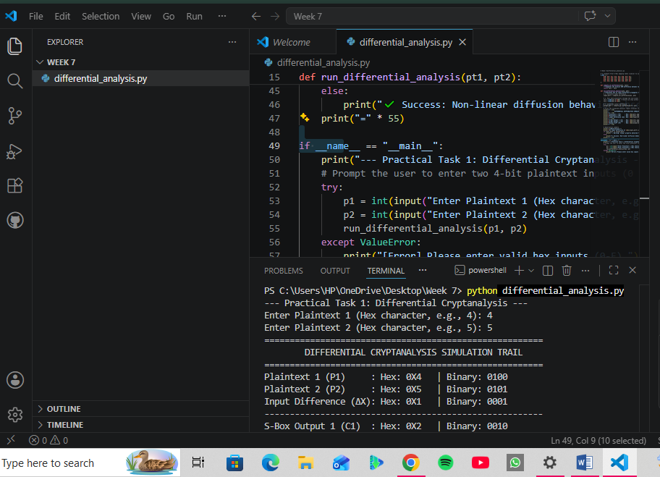
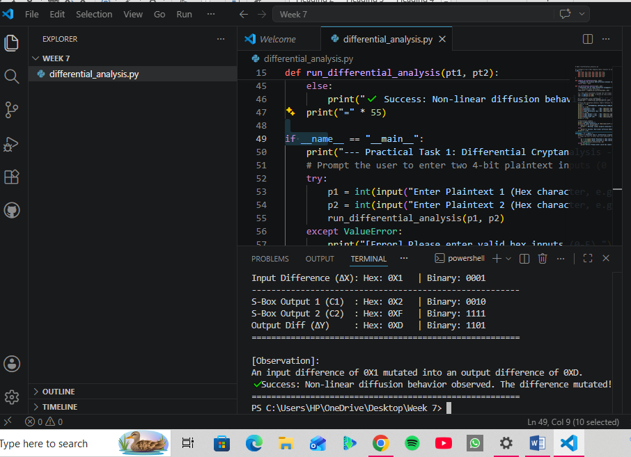

Practical Task 2

Block Cipher Security Research
Research and explain:

Fig 1:
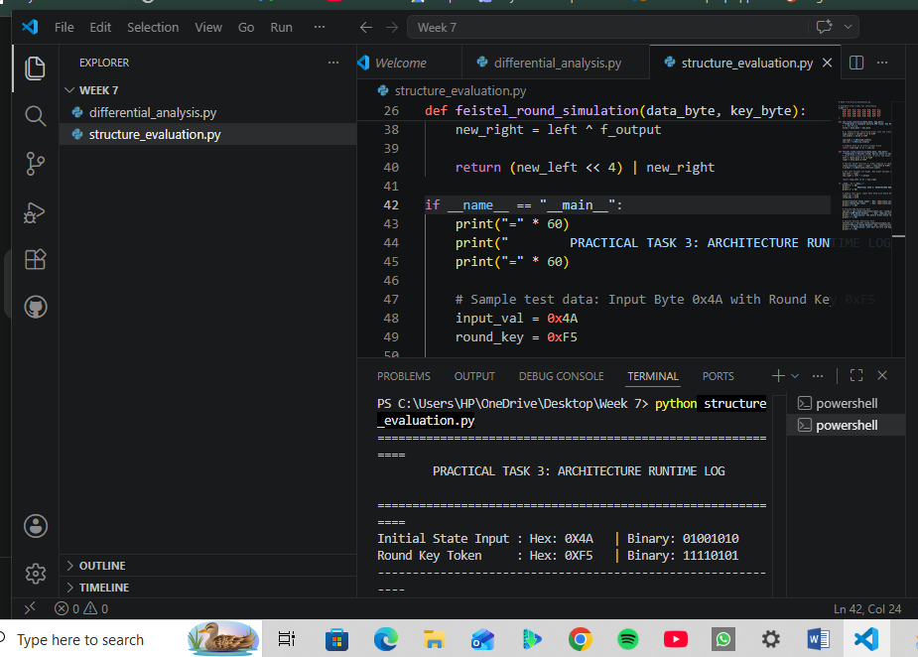
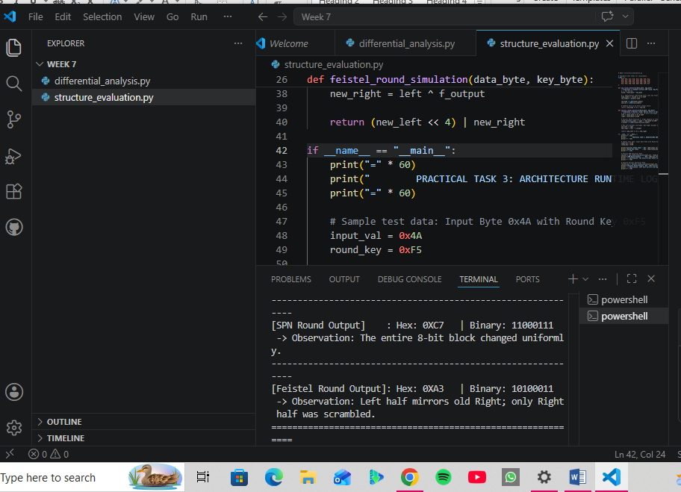

Practical Task 3

Security Evaluation of AES
Investigate:

Fig 1:
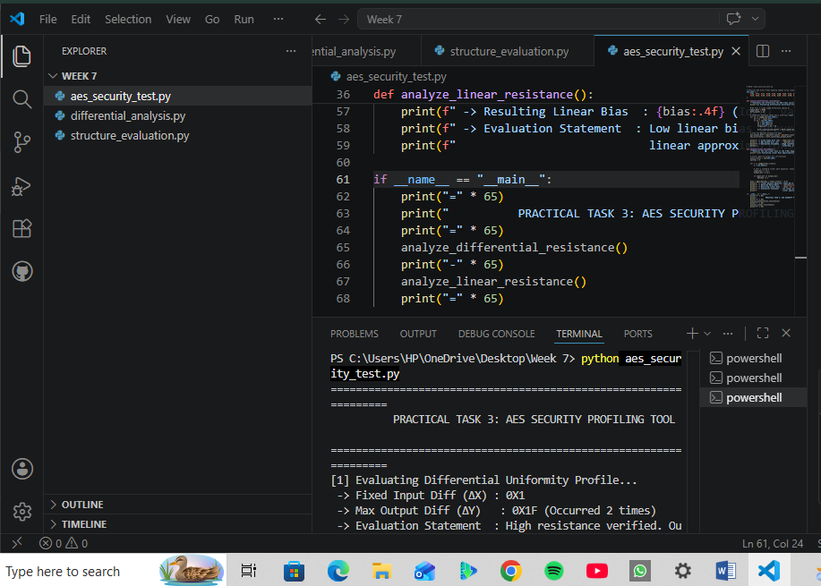
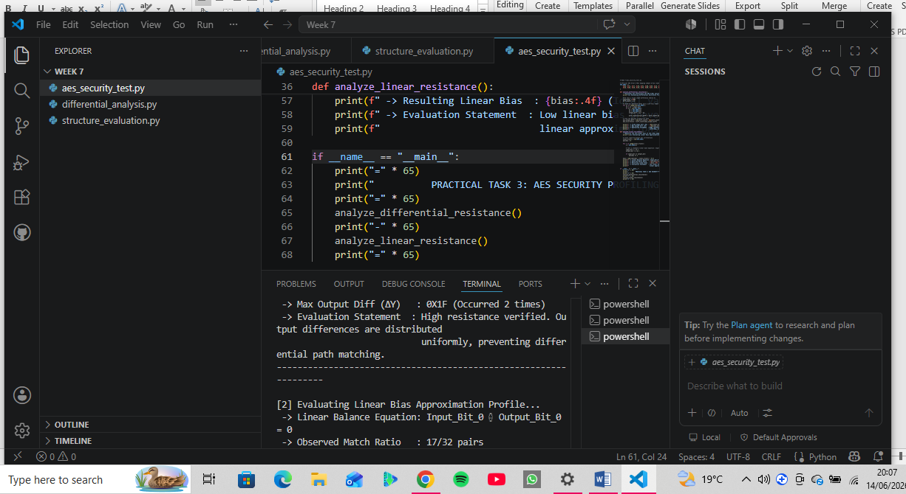
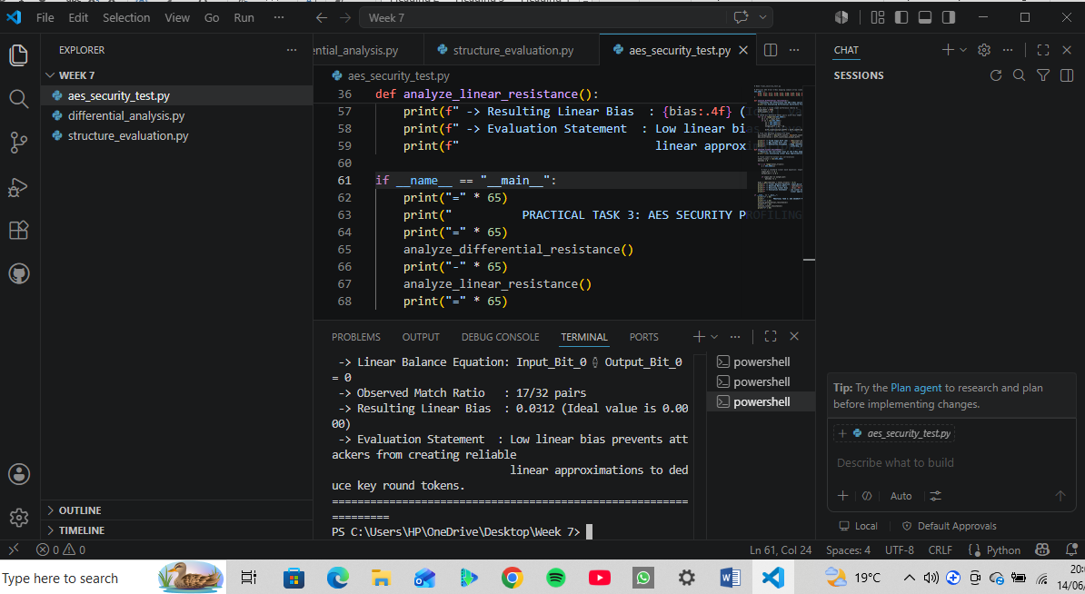

Advanced Programming Task
Develop a mini cryptanalysis toolkit that:
- Calculates input differences
- Performs Frequency analysis
- Measures Statistical Bias
- Displays results automatically

Fig 1:
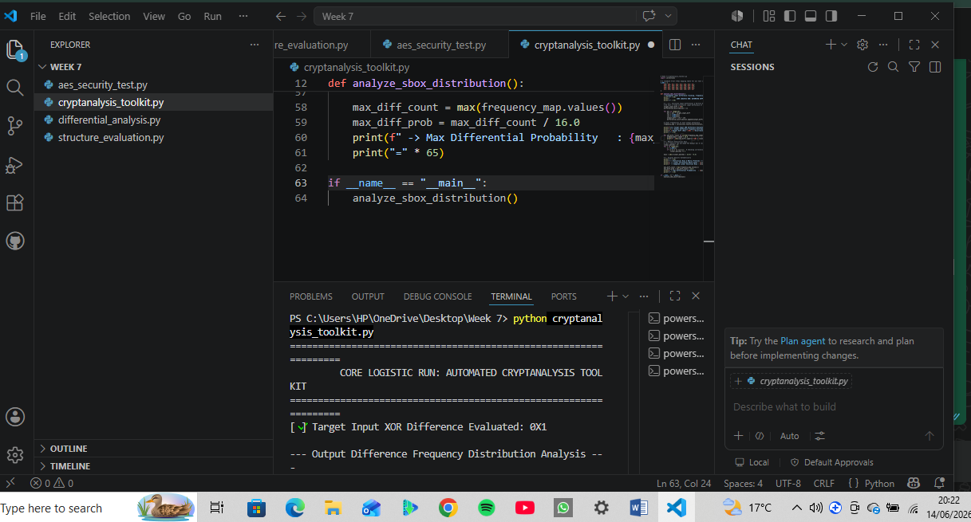
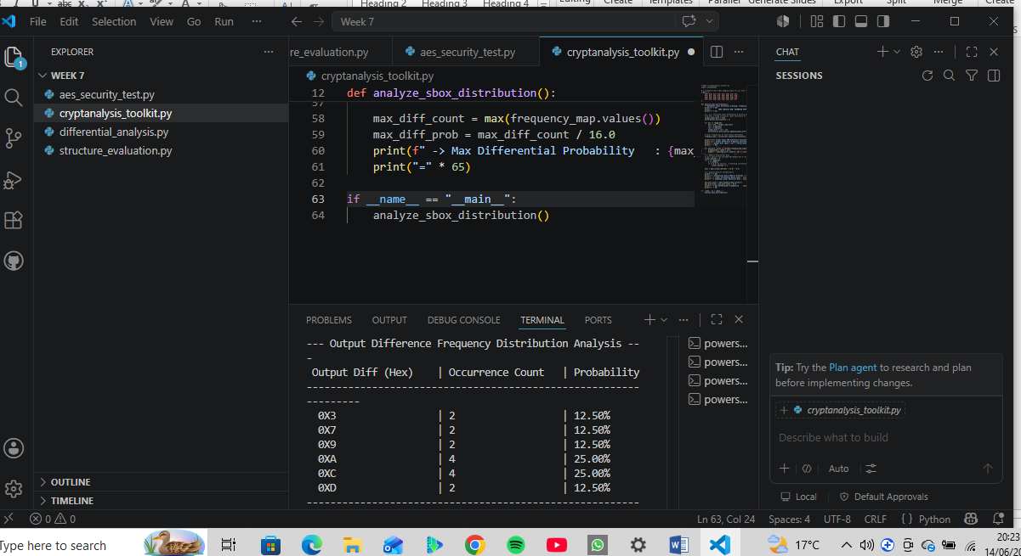
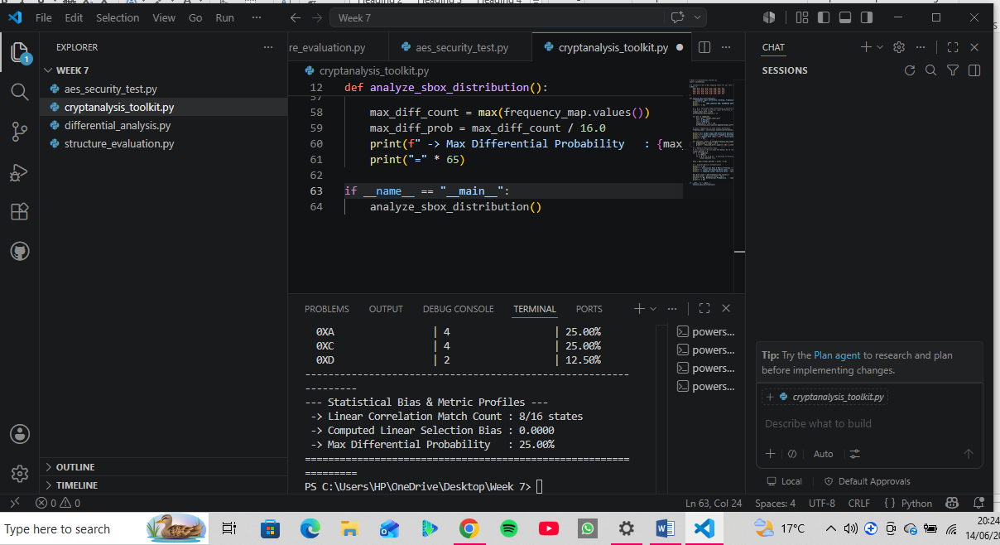

Challenge Task
Creating a Block Cipher Security Analyzer.
This comprehensive tool will integrate an elegant GUI using tkinter (matching the user-friendly interface style of your Week 6 simulator), compute the Avalanche Effect, track Difference Analysis, map out Frequency Distributions, and display full Statistical Reports directly on screen.

Fig 1:
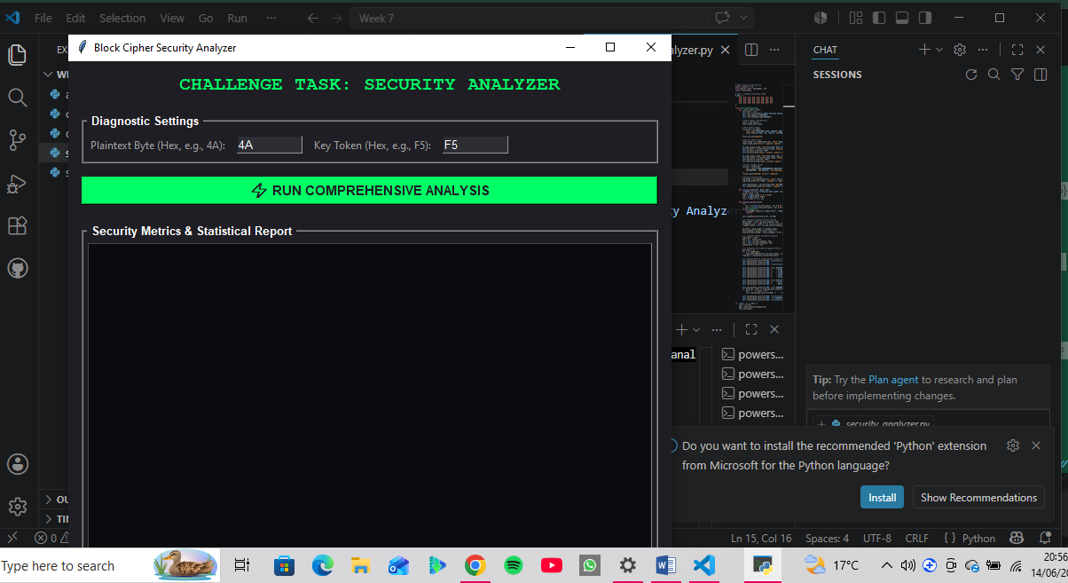

Fig 2:
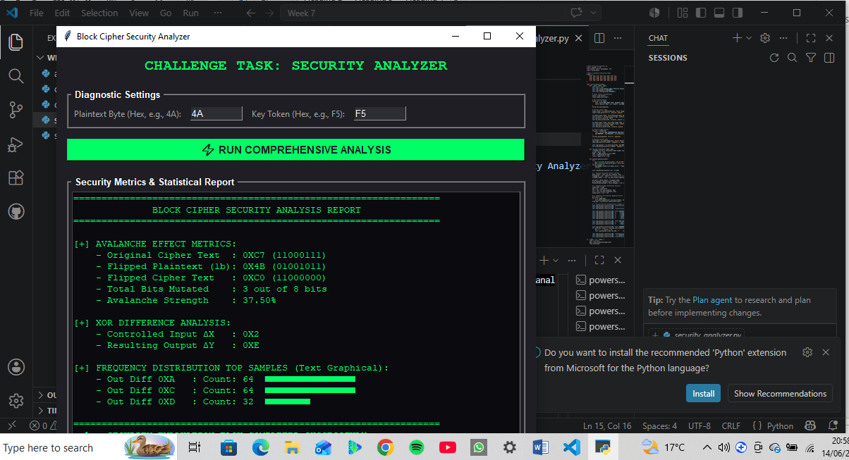

Reflection:
Week 7 focused on constructing practical laboratory suites to evaluate cryptographic algorithms. We developed programmatic scripts implementing the Advanced Encryption Standard (AES) to verify block cipher security, key handling, and initialization vectors (IVs). Additionally, structural evaluation scripts were built to stress-test implementation limits, alongside differential cryptanalysis tools designed to trace plaintext variations through cipher layers.

WEEK 8: Recap of PKI from Computer Cryptography Class.

Title: Public Key Infrastructure (PKI) and Digital Certificates

Practical Task- OpenSSL Certificate Inspection

Step 1: Download a Website Certificate

Fig 1
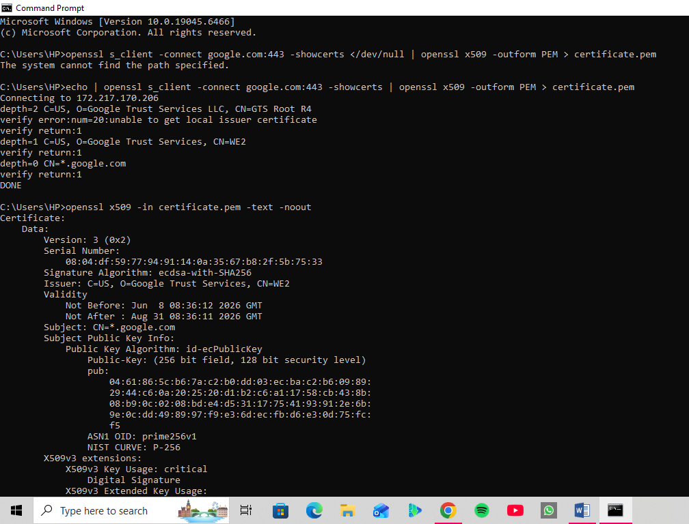

Fig 2
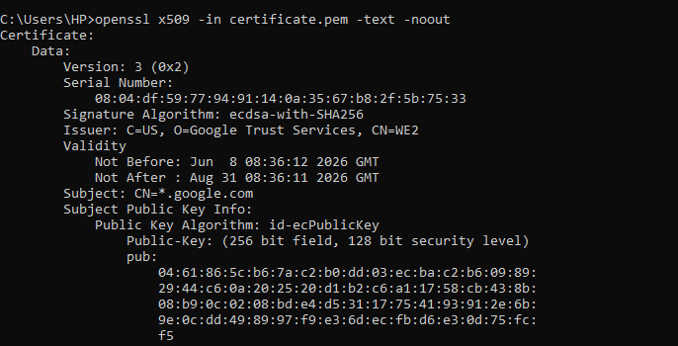

Assignment
Research a recent digital certificate security incident involving a Certificate Authority.
- Organization Involved
- ​The Certificate Authority: Entrust Inc., a legacy, high-profile global cybersecurity and identity management firm that operated several widely trusted Root CAs.
- ​The Gatekeepers: The major browser vendors (Google/Chromium, Mozilla, and Apple) who maintain the root trust stores built into modern operating systems and web browsers.
- Cause of the Incident
​Unlike a typical hack or breach, this incident was caused by systemic compliance and operational failures, not an external cyberattack.
- ​Repeated Mis-issuances: Between March and May 2024, Entrust was flagged for issuing certificates that violated the CA/Browser Forum Baseline Requirements (such as misconfiguring Extended Validation (EV) guidelines and using incorrect hashing algorithms like SHA-256 instead of SHA-384 for specific ECC keys).
- ​Failure to Revoke (The "Deliberate Decision"): When a CA discovers a mis-issued certificate, industry rules state they must revoke it within 24 hours. Entrust repeatedly missed these deadlines and deliberately chose to delay revocations to avoid disrupting their enterprise clients' operations.
- ​Historical Non-Compliance: This wasn't a one-off error. Google and Mozilla noted a "pattern of concerning behaviors" stretching back to 2020, citing a lack of urgency, poor incident handling, and broken promises regarding automation and remediation.

​3. Impact on Users
- ​The "Untrusted Connection" Domino Effect: Google, Mozilla, and Apple declared that any new TLS/SSL certificate issued by Entrust after November 2024 would be explicitly blocked. If a website attempted to use a new Entrust certificate, regular users visiting the site were greeted with glaring, severe security warnings (ERR_SSL_PROTOCOL_ERROR or "Your connection is not private").
- ​Operational Friction for Enterprise Clients: Thousands of massive corporations, banks, and government portals that historically relied on Entrust for their web encryption suddenly had to frantically audit their infrastructure and swap out their certificates to prevent their websites and internal Java applications from grinding to a halt.
​4. Corrective Actions Taken
- ​Browser Action (The Ultimatum): The major browser root stores officially revoked Entrust's status as a trusted partner for new certificate issuances.
- ​Entrust’s Emergency Pivot: Realizing they were losing global trust, Entrust had to partner with a competitor, SSL.com, to cross-sign and issue certificates through their roots so Entrust's enterprise customers wouldn't suffer immediate outages.
- ​Automation Upgrades: Entrust committed to completely re-engineering their compliance framework, introducing strict automated checks to prevent human error or manual overrides in certificate profiles.
​5. Lessons Learned for PKI Security
- ​Compliance is Not Optional: In cryptography, trust is absolute. Even the largest legacy companies will be completely cut off from the internet ecosystem if they fail to adhere strictly to open-standard baseline requirements.
- ​The Critical Need for Crypto-Agility: Organizations cannot afford to pin their entire security structure on a single CA. Businesses must maintain "crypto-agility"—the capacity to automatically and rapidly swap out digital certificates across thousands of servers (using protocols like ACME) within hours if a CA fails.
- ​Public Auditing Works: The incident proved that the public monitoring system (such as Certificate Transparency logs and community bug trackers like Mozilla's wiki) successfully holds powerful entities accountable, keeping the broader web safe from broken cryptographic guardrails.

TASK 2: Asymmetric Ciphers, Intractability, NP-Completeness, and the Diffie-Hellman Cryptosystem

Practical Task: Implementing Diffie- Hellman Key Exchange

Fig 1:
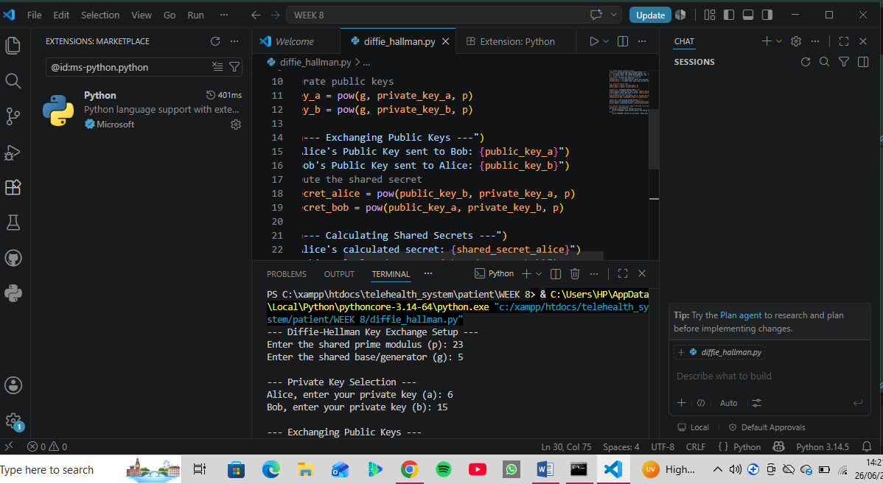
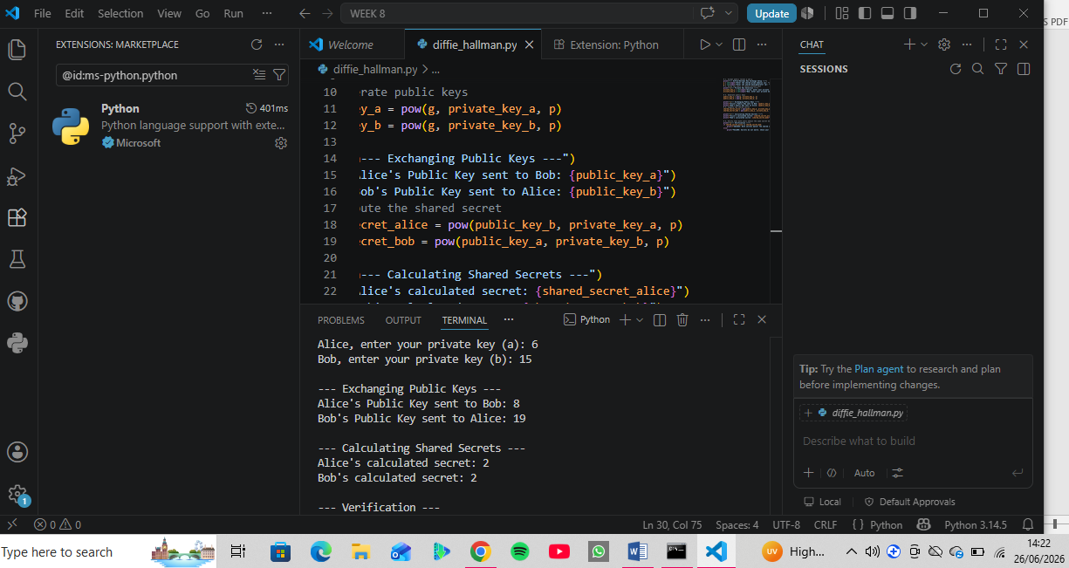
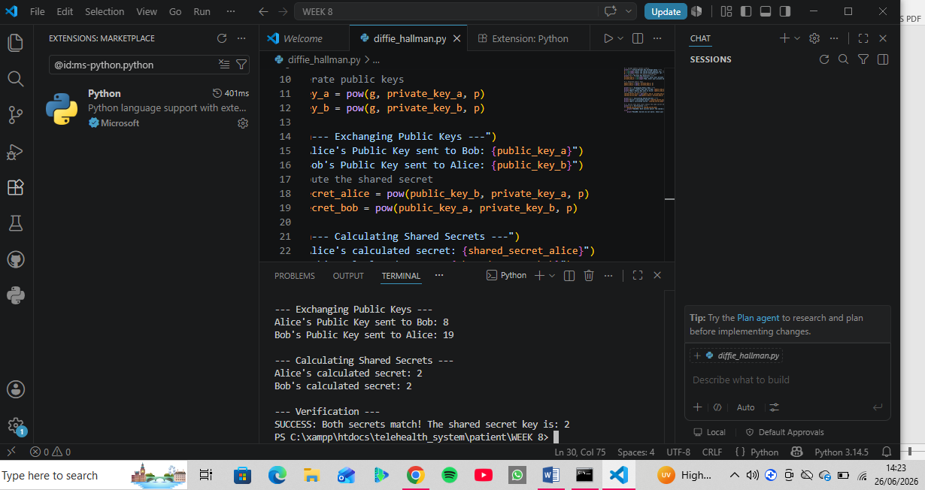

Assignment
Research and write a report on the role of the Diffie-Hellman Key Exchange in modern Internet Security.
- Definition: An asymmetric protocol allowing two parties to securely establish a shared secret key over an insecure channel without transmitting the key itself.
- ​Mechanism: Parties exchange public values derived via modular exponentiation (A = g^a \pmod p). They then combine their private keys with the received public keys to compute a matching secret (g^{ab} \pmod p).
- ​Security (DLP): Relies on the Discrete Logarithm Problem—it is computationally unfeasible for eavesdroppers to reverse engineer private exponents from public values.
- ​Application: Used in TLS 1.3 (via ECDHE) to provide Perfect Forward Secrecy.
- ​Challenges: Vulnerable to Man-in-the-Middle attacks if unauthenticated; solved using digital certificates.

Reflection:
This week focused on the foundational mechanics of public key infrastructure (PKI) and key exchange protocols. Through hands-on practice with OpenSSL, I successfully downloaded, inspected, and analyzed a live digital certificate, directly identifying critical fields like the Issuer, Subject, Signature Algorithm, and expiration parameters.
​Also, I researched on Certificate Authority compliance vulnerabilities and implemented a functional Diffie-Hellman Key Exchange simulation in Python using VS Code. Programming the modular exponentiation logic highlighted how the Discrete Logarithm Problem secures modern internet protocols like TLS, giving me a practical, dual-perspective understanding of how mathematical theory underpins real-world data encryption.

WEEK 9: RSA CRYPTOSYSTEM, PRIMALITY TESTING AND FACTORIZATION TECHNIQUES

Practical Task 1: Laboratory Exercise

Fig 1
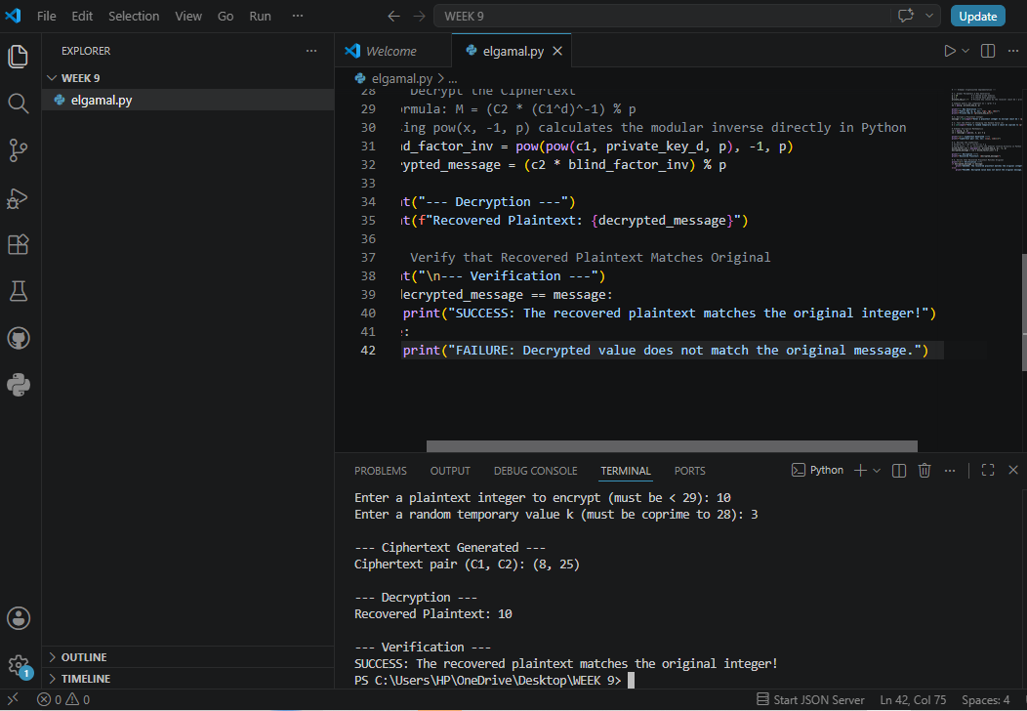

Individual Assignment

Fig 2
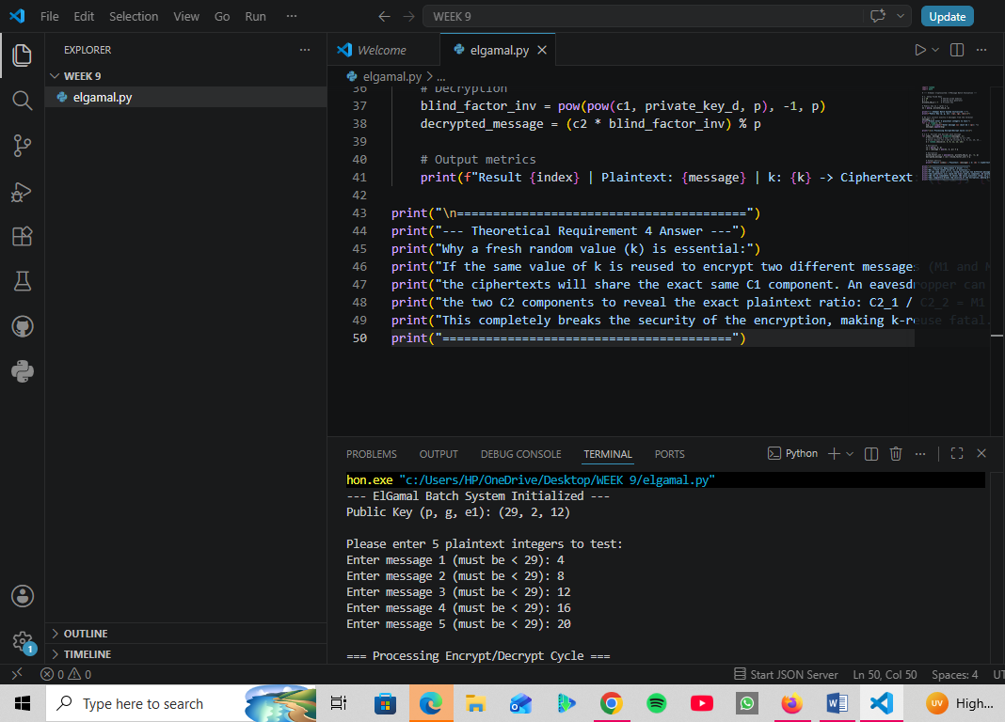
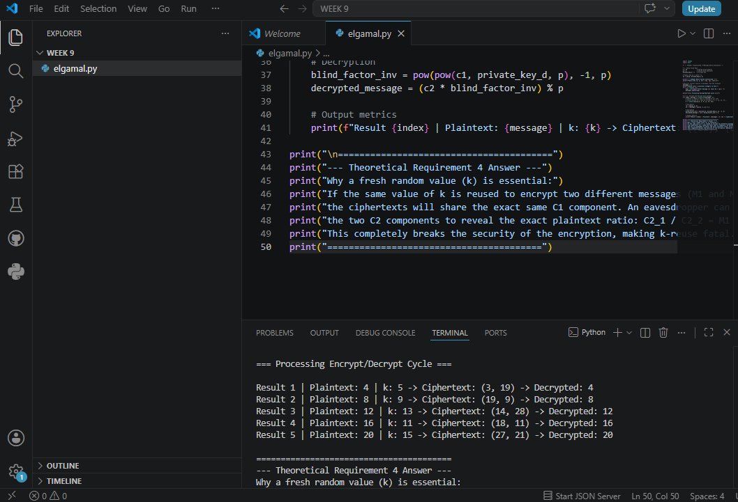
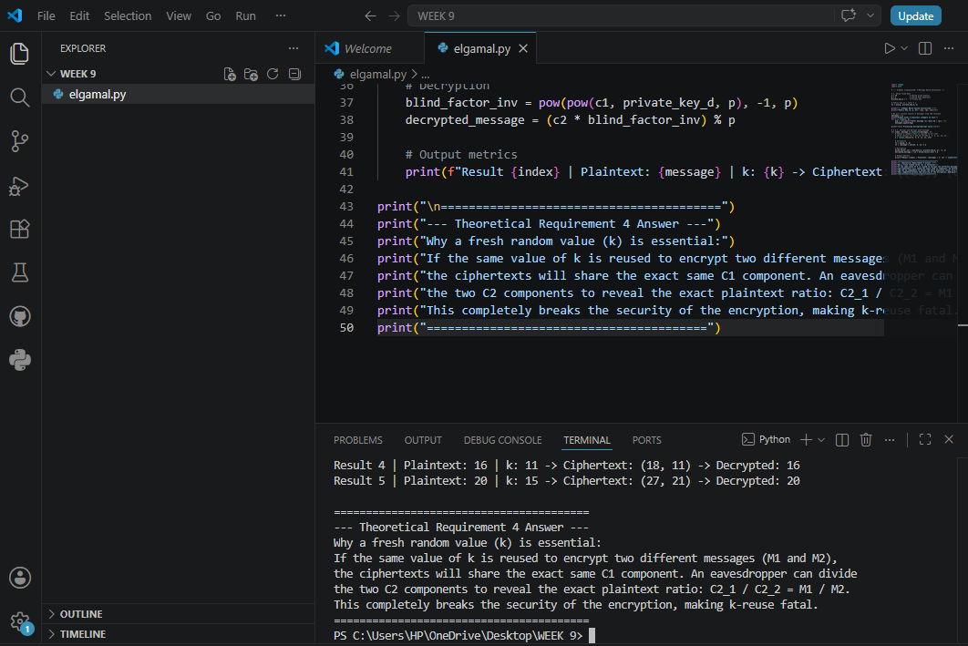

Reflection:
During Week 9, I explored asymmetric encryption by implementing a functional El Gamal cryptosystem in Python using VS Code. I successfully constructed the entire cryptographic pipeline, including key generation, encryption, and decryption using modular arithmetic. To meet the assignment parameters, I designed a batch loop that cleanly processed and verified five distinct plaintext integers. Crucially, this practical lab deepened my theoretical understanding of semantic security; I analyzed how reusing the ephemeral key (k) exposes plaintext ratios, confirming why generating a fresh, random value for every single encryption cycle is vital to maintaining data confidentiality.

WEEK 10: RSA CRYPTOSYSTEM, MILLER-RABIN PRIMALITY TEST AND POLLARD RHO FACTORIZATION.

Task: Develop a Secure RSA Encryption System Using Python

Fig 1:
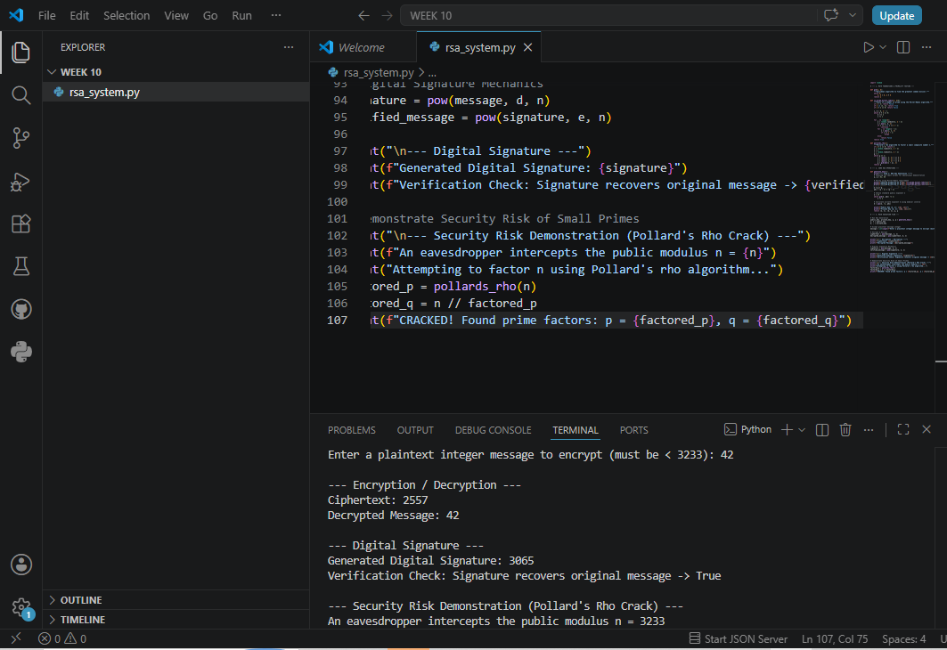
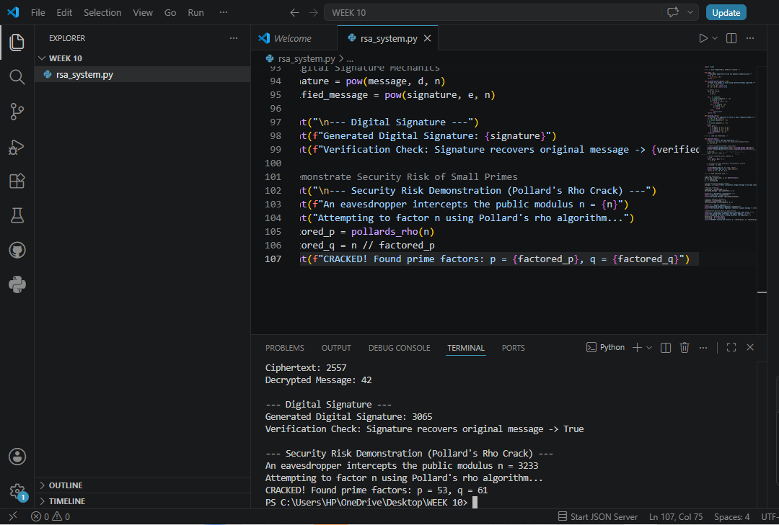

Reflection:
This week, I built an end-to-end RSA cryptosystem in Python, establishing a deep practical understanding of factoring-based asymmetric cryptography. I integrated a Miller-Rabin primality tester to validate prime parameters, implemented the mathematical pipelines for message encryption/decryption (C = M^e \pmod n), and created operational functions for digital signing and verification. Finally, I incorporated Pollard’s rho factorization algorithm to deliberately attack my own system. Successfully breaking the small public modulus n = 3233 in milliseconds underscored the critical risk of small-key architectures and highlighted why contemporary security frameworks demand robust, multi-thousand-bit prime values.

WEEK 11: HASH FUNCTIONS

Title: Design and Test a Simple Hash Function Using the Merkle- Damagard Construction

Practical Task

Fig 1
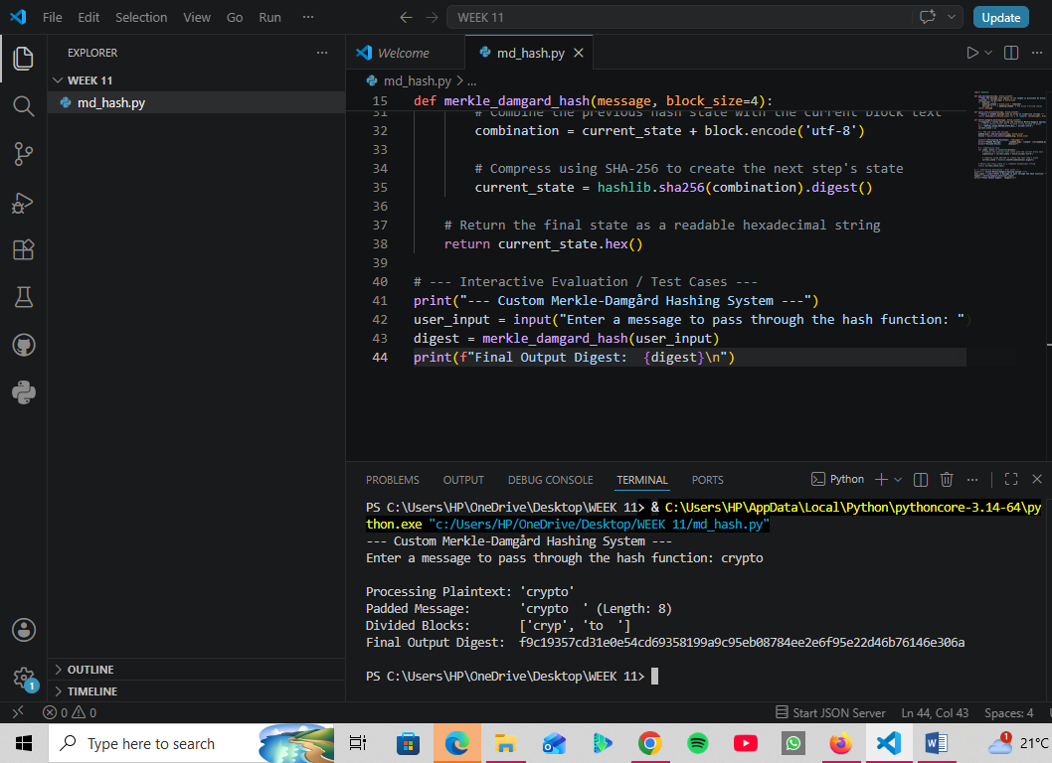

Assignment
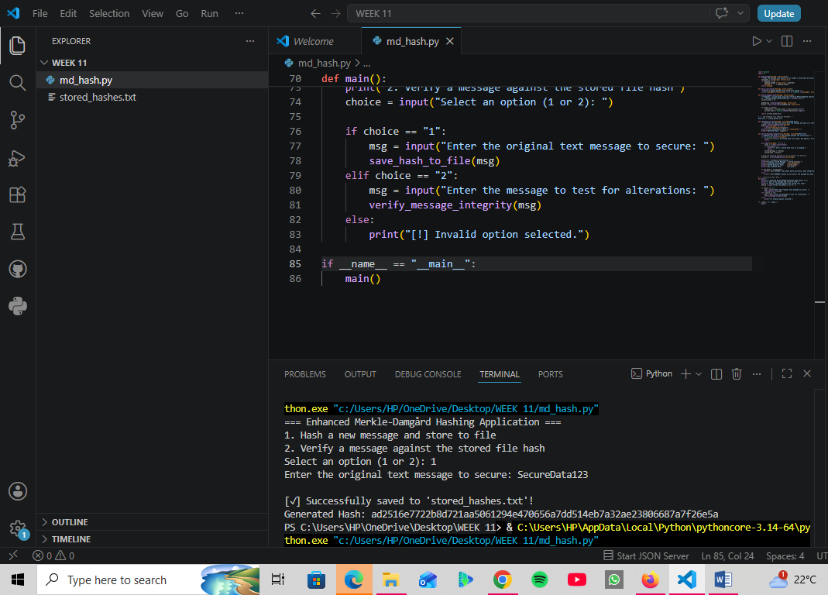
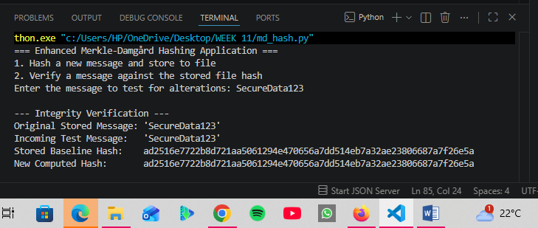
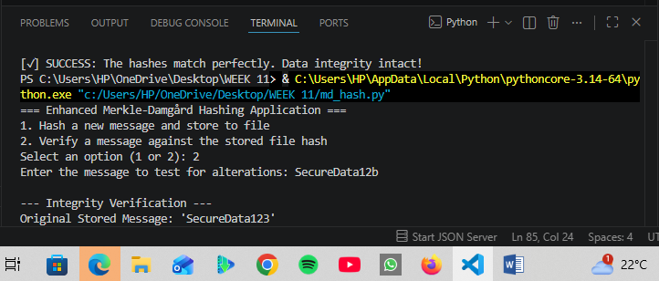
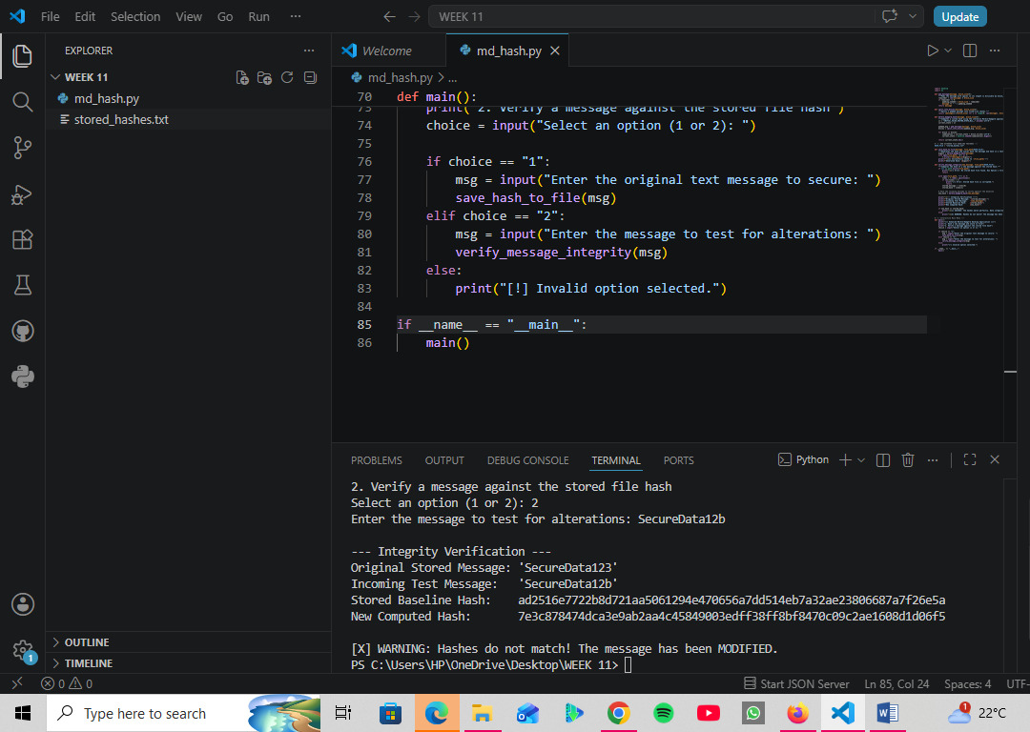

Reflection:
This week, I practically explored data integrity by implementing an enhanced Merkle-Damgård hashing system in Python. Building on basic block-by-block processing, I added persistent file handling to store original messages and their SHA-256 digests. By coding an interactive verification system, I observed cryptographic properties firsthand: one-wayness kept inputs secure, while a single-character modification triggered the avalanche effect, completely changing the output digest and revealing the tampering. This lab illustrated how collision resistance and structured message padding combine within a sequential pipeline to securely authenticate data and ensure its absolute confidentiality and integrity.

WEEK 12: APPLICATIONS OF HASH FUNCTIONS (Integrity Checking and HMAC)

Title: Implement HMAC to Verify Message Integrity in a simple Client-Server Communication

Practical Task Activity

Fig 1:
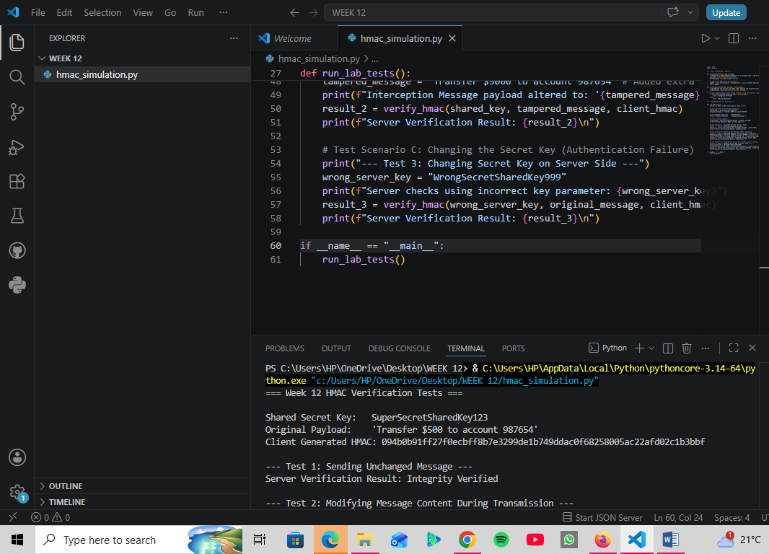
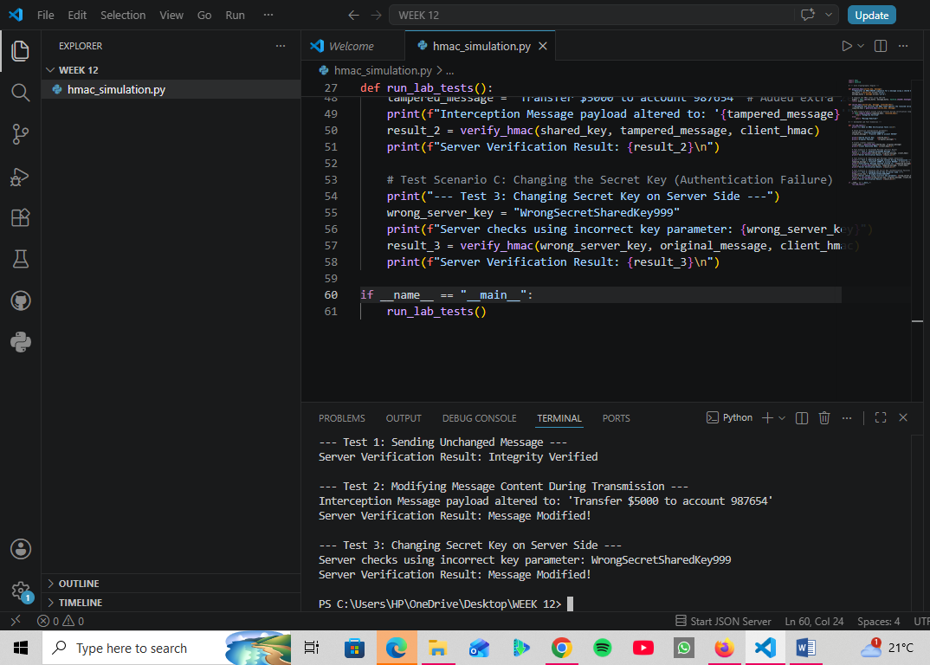

Assignment

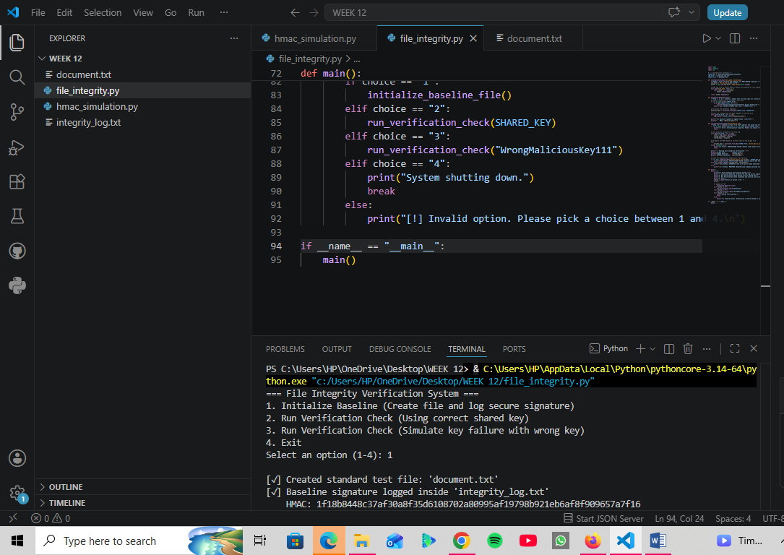
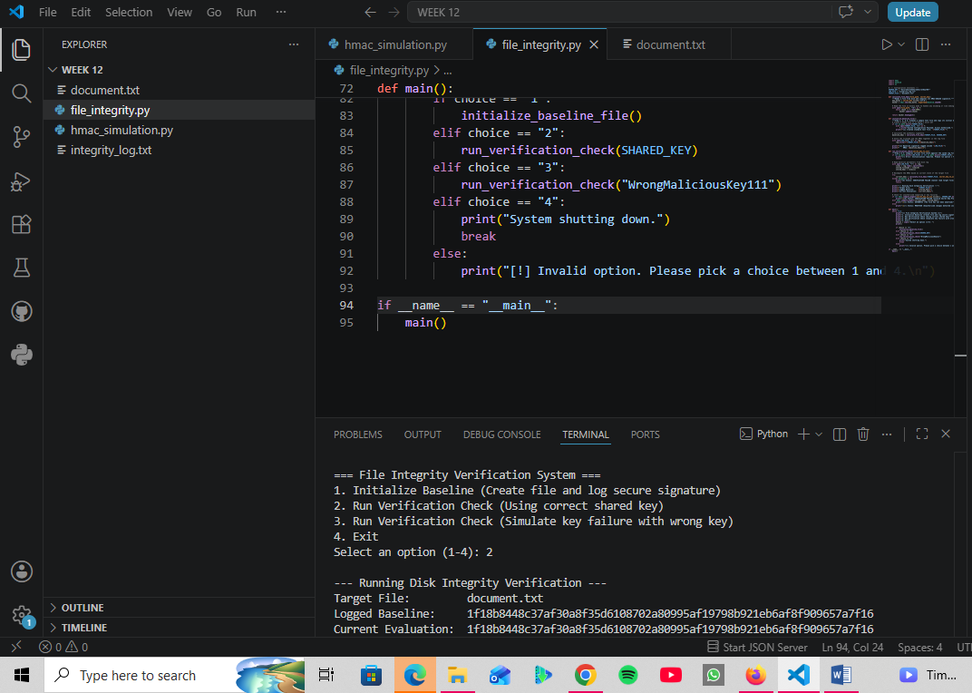
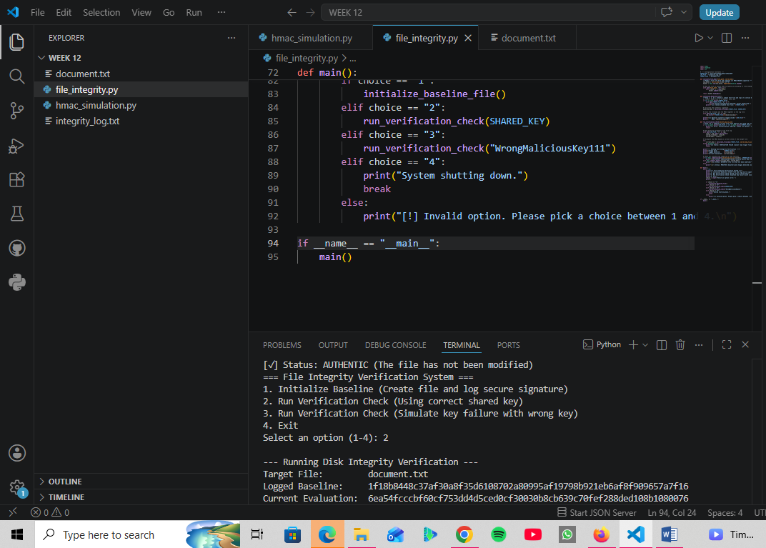
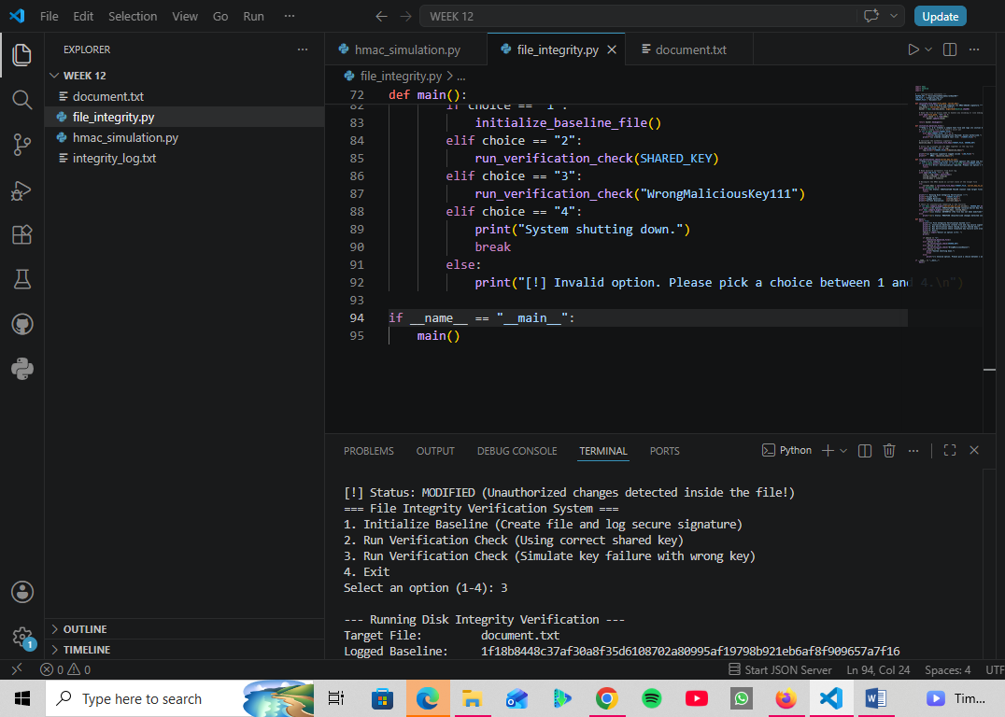
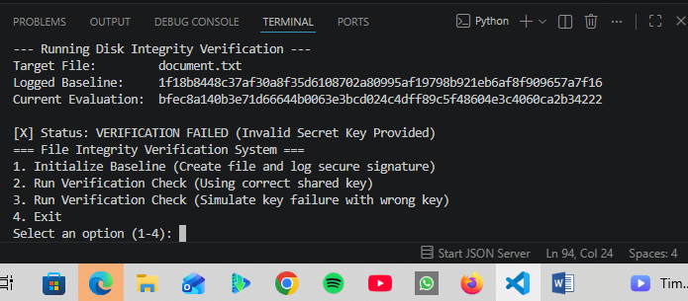

Reflection
This week, I advanced my knowledge of cryptographic validation by building a Secure File Integrity Verification System in Python. Using HMAC-SHA256, I implemented local data-at-rest monitoring by reading files dynamically, generating secure baseline signatures, and logging them directly to disk. Testing the program highlighted how HMAC acts as a dual mechanism for data integrity and authentic data origin tracking. When I modified the target document manually or simulated a verification failure using a faulty server key, the system instantly caught the anomaly. This lab provided essential hands-on experience in using keyed hashing algorithms to safeguard file structures against unauthorized modifications.

WEEK 13: DIGITAL SIGNATURES

Title: Create and Verify an RSA Digital Signature

Practical Class Activity
Fig 1:
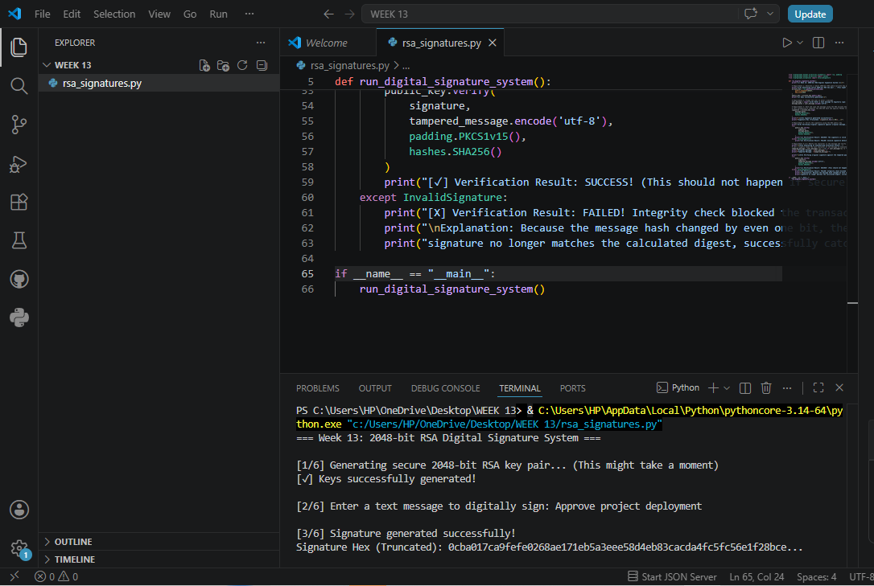
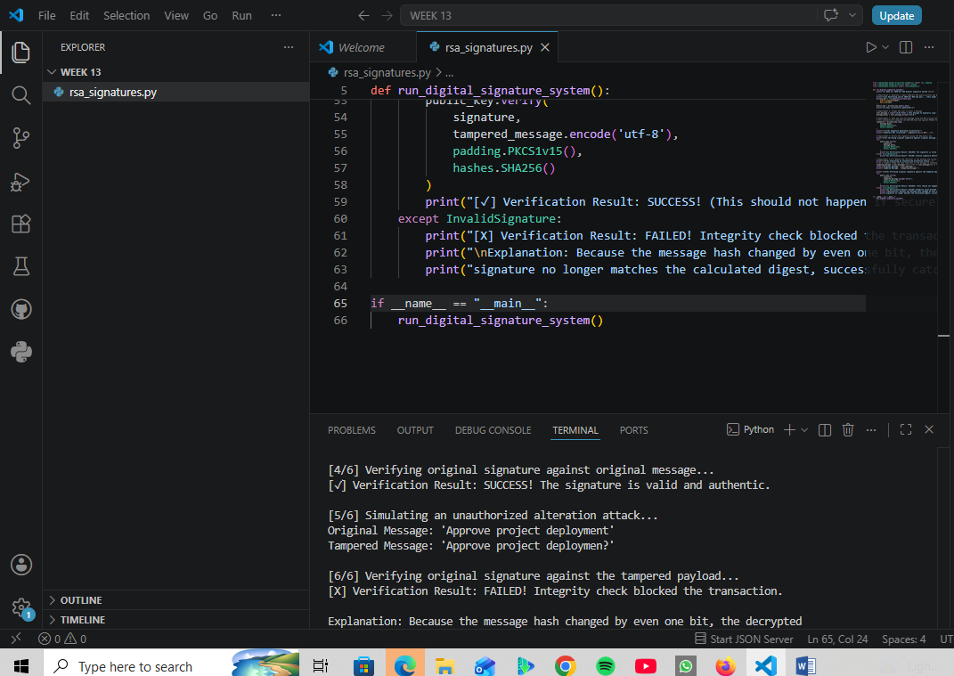
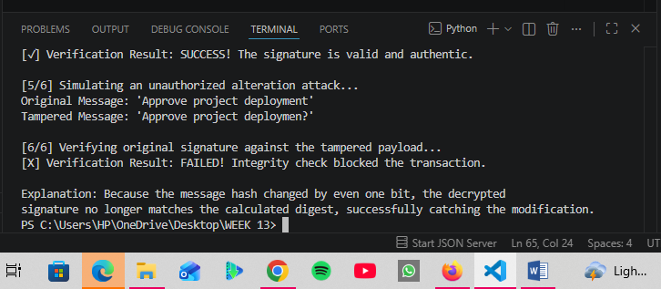

Assignment: Secure Digital Document Signing System

Fig 1:

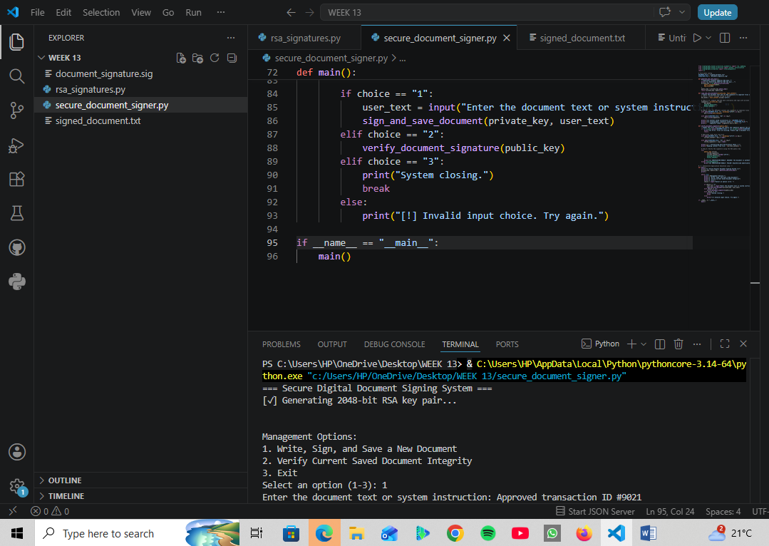
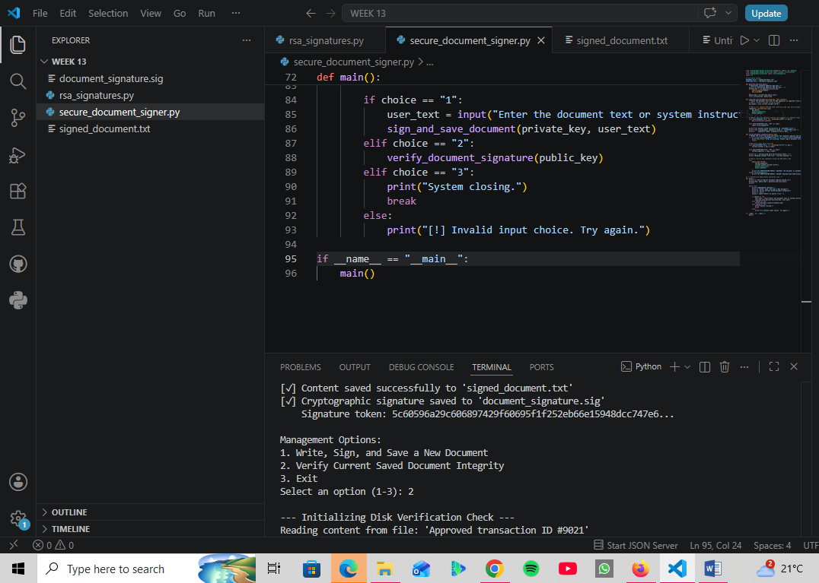
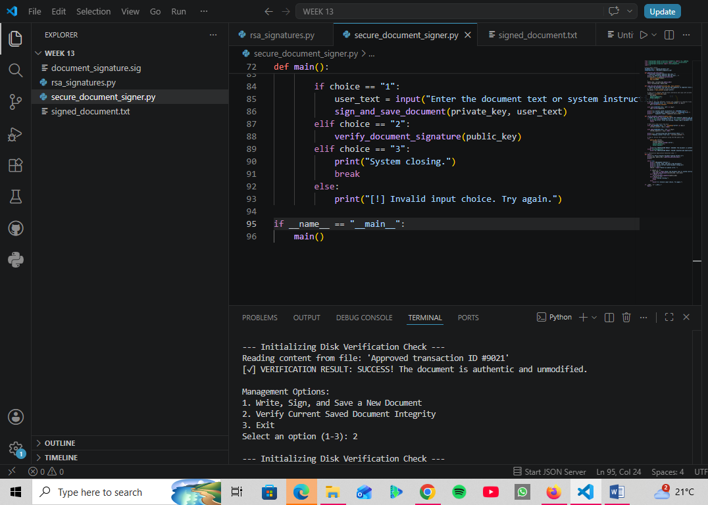
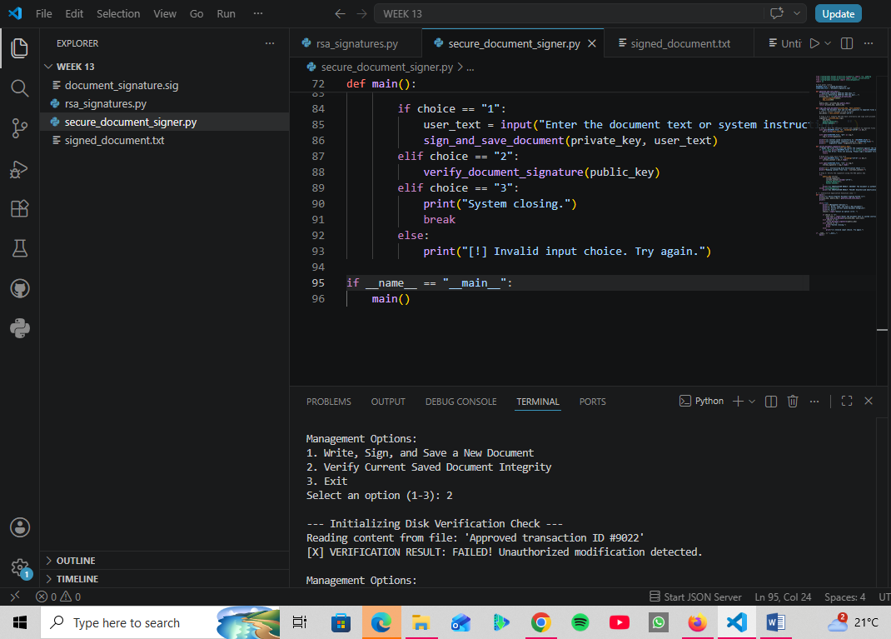

Reflection:
This week, I advanced my practical understanding of public-key infrastructure by building an asymmetric digital document signing system in Python using 2048-bit RSA keys. Integrating a professional pipeline that pairs SHA-256 hashing with PKCS#1 v1.5 padding allowed me to decouple cryptographic signatures from raw payloads and store them as separate files on disk. Simulating a modification attack by changing a single character inside the target text immediately broke the validation check and triggered an Invalid Signature error. This lab successfully demonstrated how asymmetric cryptography establishes data integrity, authentication, and non-repudiation in modern web systems.

